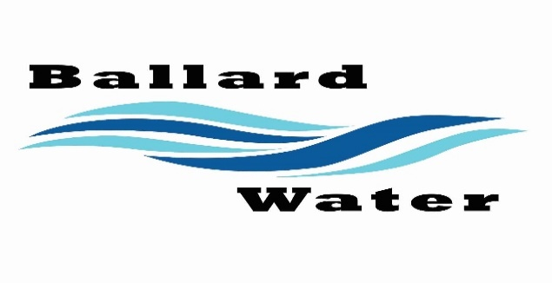

Board Chairman

Mark Reidhead

Board Members

Bob Abercrombie

Andrew Ercanbrack

Ronny Rich

Jesse Danley

2381 E. 1000 S.

Ballard, UT 84066
Phone: (435) 722-3393
Email: amcdonald@ballardcity.org

Water District Meeting
VISITORS
Ryan Richens
Craig Nebeker
James Costello
Loni Costello
Jeffrey Baker

September 19, 2023, 5:30 pm

MINUTES

Item

CALL WATER BOARD MEETING TO ORDER

Welcome and Roll Call – Chairman Mark Reidhead welcomed all in attendance and called roll. Those in attendance were Board Members Jesse Danley, Ronny Rich, Andrew Ercanbrack, Bob Abercrombie, and Secretary Anissa McDonald. Secretary Kaelyn Meyers was excused.

Prayer – Mark Reidhead

Pledge of Allegiance- Said by all in attendance.

- FIRE SUPPRESSION– James & Loni Costello
Chairman Mark Reidhead stated that upon completion of the hydraulic model testing there is no fire suppression for the property located at approximately 3100 east 3000 north. Chairman Mark Reidhead said that there will be a letter available for them that they can pick up tomorrow stating that there is no fire suppression.

- FIRE SUPPRESSION – Joe Archer
Not in attendance.

- PARAMETERS RESOLUTION FOR WATER REVENUE BONDS –
A RESOLUTION AUTHORIZING NOT MORE THAN $5,000,000 TAXABLE WATER REVENUE BONDS, IN ONE OR MORE SERIES, FOR WATER SYSTEM IMPROVEMENTS, AND RELATED IMPROVEMENTS; PROVIDING FOR THE PUBLICATION OF A NOTICE OF PUBLIC HEARING AND BONDS TO BE ISSUED; FIXING THE MAXIMUM PRINCIPAL AMOUNT, INTEREST RATE, MATURITY, AND DISCOUNT OF THE BONDS; PROVIDING FOR THE RUNNING OF A CONTEST PERIOD; AND RELATED MATTERS.
Motion made by Board Member Bob Abercrombie to accept parameter resolution for water revenue bonds #092023-001, 2nd by Board Member Jesse Danley. All in favor.
YEA NAY
Board Members
Jesse Danley
Ronny Rich
Andrew Ercanbrack
Bob Abercrombie
Mark Reidhead

- CLOSED SESSION –
Motion made by Board Member Jesse Danley to close our regular Water Board Meeting and open the closed session, 2nd by Board Member Andrew Ercanbrack. All in favor.
YEA NAY
Board Members
Jesse Danley
Ronny Rich
Andrew Ercanbrack
Bob Abercrombie
Mark Reidhead
Chairman Mark Reidhead stated that the purpose of the closed session is to discuss the purchase of location for a well.
Motion made by Board Member Jesse Danley to close the closed session and open our regularly scheduled Water Board Meeting, 2nd by Board Member Andrew Ercanbrack. All in favor.
YEA NAY
Board Members
Jesse Danley
Ronny Rich
Andrew Ercanbrack
Bob Abercrombie
Mark Reidhead

- ENGINEER PROJECT UPDATES –
Water Well Project -- Jeff Baker from Jones & DeMille discussed waterline for proposed water well. We should be under budget even though it will be a longer line than what was previously proposed.
1500 E. Roadway Repair -- Johansen Construction Inc will excavate a couple of holes in the road on 1500 east.
Lead & Copper Pipe Exploration Project -- Craig Nebeker discussed lead and copper inventory and proposed template and funds that can be used.

- REVIEW & CORRECT MINUTES –
- August 15, 2023
Motion made by Board Member Andrew Ercanbrack to accept the minutes of August 15, 2023, as written, 2nd by Board Member Ronny Rich. All in favor.
YEA NAY
Board Members
Jesse Danley
Ronny Rich
Andrew Ercanbrack
Bob Abercrombie
Mark Reidhead

- FOLLOW-UP ON PAST MINUTES
No follow up.

- FINANCES: Checks, Statements, Reports and Budget
Checks and finances were gone over and approved.

- ADJOURN WATER BOARD MEETING
Motion made by Board Member Jesse Danley to adjourn meeting at 6:30 p.m., 2nd by Board Member Ronny Rich. All in favor.

YEA NAY
Board Members
Jesse Danley
Ronny Rich
Andrew Ercanbrack
Bob Abercrombie
Mark Reidhead

Chairman Mark Reidhead Date

Secretary Anissa McDonald Date

Approved Signed Copy filed in the Ballard City Offices

