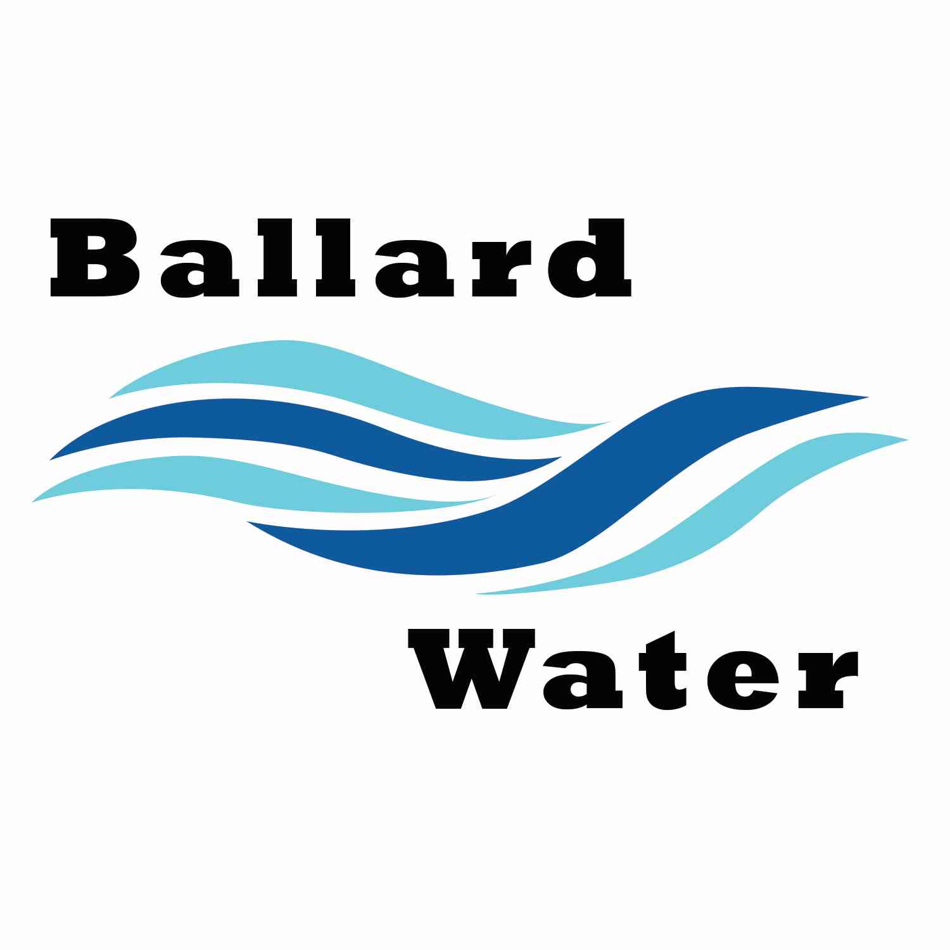

2381 E. 1000 S.

Ballard, UT 84066
Phone: (435) 722-3393
Email: amcdonald@ballardcity.org

Board Chairman

Mark Reidhead

Board Members

Cory O’Driscoll

Andrew Ercanbrack

Ronny Rich

Jesse Danley

VISITORS
Craig Nebeker
Al Kettle
Jeffrey Baker
Rick Young

Water District

SEPTEMBER 17, 2024, 5:30 pm

MINUTES

Item

CALL WATER BOARD MEETING TO ORDER

Welcome and Roll Call – Chairman Mark Reidhead welcomed all in attendance and called roll. Those in attendance were Board Members Jesse Danley, Ronny Rich, Andrew Ercanbrack, Cory O’Driscoll, and Secretary Kaelyn Meyers.

Prayer – Ronny Rich

Pledge of Allegiance- Was said by all in attendance.

- WATER DISPUTE – Carol Boyle
Was not in attendance.

- ENGINEER PROJECT UPDATES –
Well Update – Craig Nebeker from CRS Engineers gave an update on the water well, stating that they finally hit an aquifer at about 300 feet. At about 350 feet there was a discussion regarding the water. When they get deep enough that is when they will seal the top and do some pump testing. There was a problem with the casing and getting the grout between the soil and the casing which caused some delay but they do have a tool that will pull the existing casing and get that grout done.
It was approx. 350 feet to the first formation then they decided to go to about 400 feet to find another formation. It was suggested that they continue further and try to get as deep as 500 feet.
Water Manager Ben Mower and Craig have talked, and they feel comfortable with going to 500 feet but if we want it to go deeper, that will need to come from the board. When the drilling is done, the logging and the testing will need to be done.
Chairman Mark Reidhead asked how deep we feel comfortable drilling considering that the cost will increase about $50,000 with every 100 feet we go deeper. Ben explained that as the process of the drilling goes on, we will need to probably have to go after another grant / loan from CIB to finish the process. We did know that this would cost more money than what the grant would cover. Currently we don’t have to raise any rates but if another $1.5 million were needed, we might have to raise rates. Board Member Andrew Ercanbrack feels that we should go a little deeper to see what we can get. Craig Nebeker stated that he would like to see what we have at 500 feet and then decide and if we hit one more formation then we stop, but if we don’t hit one by 500 feet, we can go a little more, but we might be wasting money if we go much over another 100.
It was decided that we would try to keep it at 500 feet and maybe just over to stop.
Lead & Copper Project – there has been some medical emergency with the contractor, but they should have things done before the deadline and have it into the state.
Well Environmental Update – Jeff Baker from Jones & DeMille stated that the army corps of engineers has been dragged out on reviewing anything. What we applied for there is no permit needed. The first review was in November, and it took 5 months for them to respond, and they did not like that the review was done in November. So, we had to redo the review. Closing on the funding might be delayed if we must phase the project.

- REVIEW & CORRECT MINUTES –
- August 20, 2024
Motion made by Board Member Ronny Rich to approve the minutes of August 20, 2024 as written, 2nd by Board Member Cory O’Driscoll. All in favor.
YEA NAY
Board Members
Mark Reidhead
Jesse Danley
Ronny Rich
Andrew Ercanbrack
Cory O’Driscoll

- FOLLOW-UP ON PAST MINUTES-
Right-of-way Pipeline – Ben Mower stated that there was a question from a resident that states that the Montez creek right of way pipeline is going through his property. Craig Nebeker stated that we have the documentation showing we have the right of way, and that the resident should be the one that proves we are wrong. Do we pay to find out where the line is or put the burden on the resident to find out. Board Member Ronny Rich stated that if we leave it to the resident, it might not be good. The resident would like a water connection in lieu of cash but he would like to get the actual location recorded. Board Member Ronny Rich stated that the resident might be willing to wait to see what the well does. Chairman Mark Reidhead stated that we need to find out where our line is anyway so we might want to go ahead with doing a survey for the right-of -way. Jeff Baker suggested that we get a title search done on that property also.
Rick Young – asked about his property on 3000 North. Larry Rich’s niece would like to purchase some property and build a home but was denied from getting a hook-up. There was a discussion regarding the water hook-ups. Jesse Knight was able to build a home up there. He sees growth all around him with approvals to build and feels like he is still trying to just be able to sell lots to build.

- FINANCES: Checks, Statements, Reports and Budget
Checks and finances were gone over and approved.

- ADJOURN WATER BOARD MEETING

Motion made by Board Member Cory O’Driscoll to adjourn meeting, 2nd by Board Member Jesse Danley. All in favor.
YEA NAY
Board Members
Mark Reidhead
Jesse Danley
Ronny Rich
Andrew Ercanbrack
Cory O’Driscoll

_______
Chairman Mark Reidhead Date

_
Secretary Anissa McDonald Date

