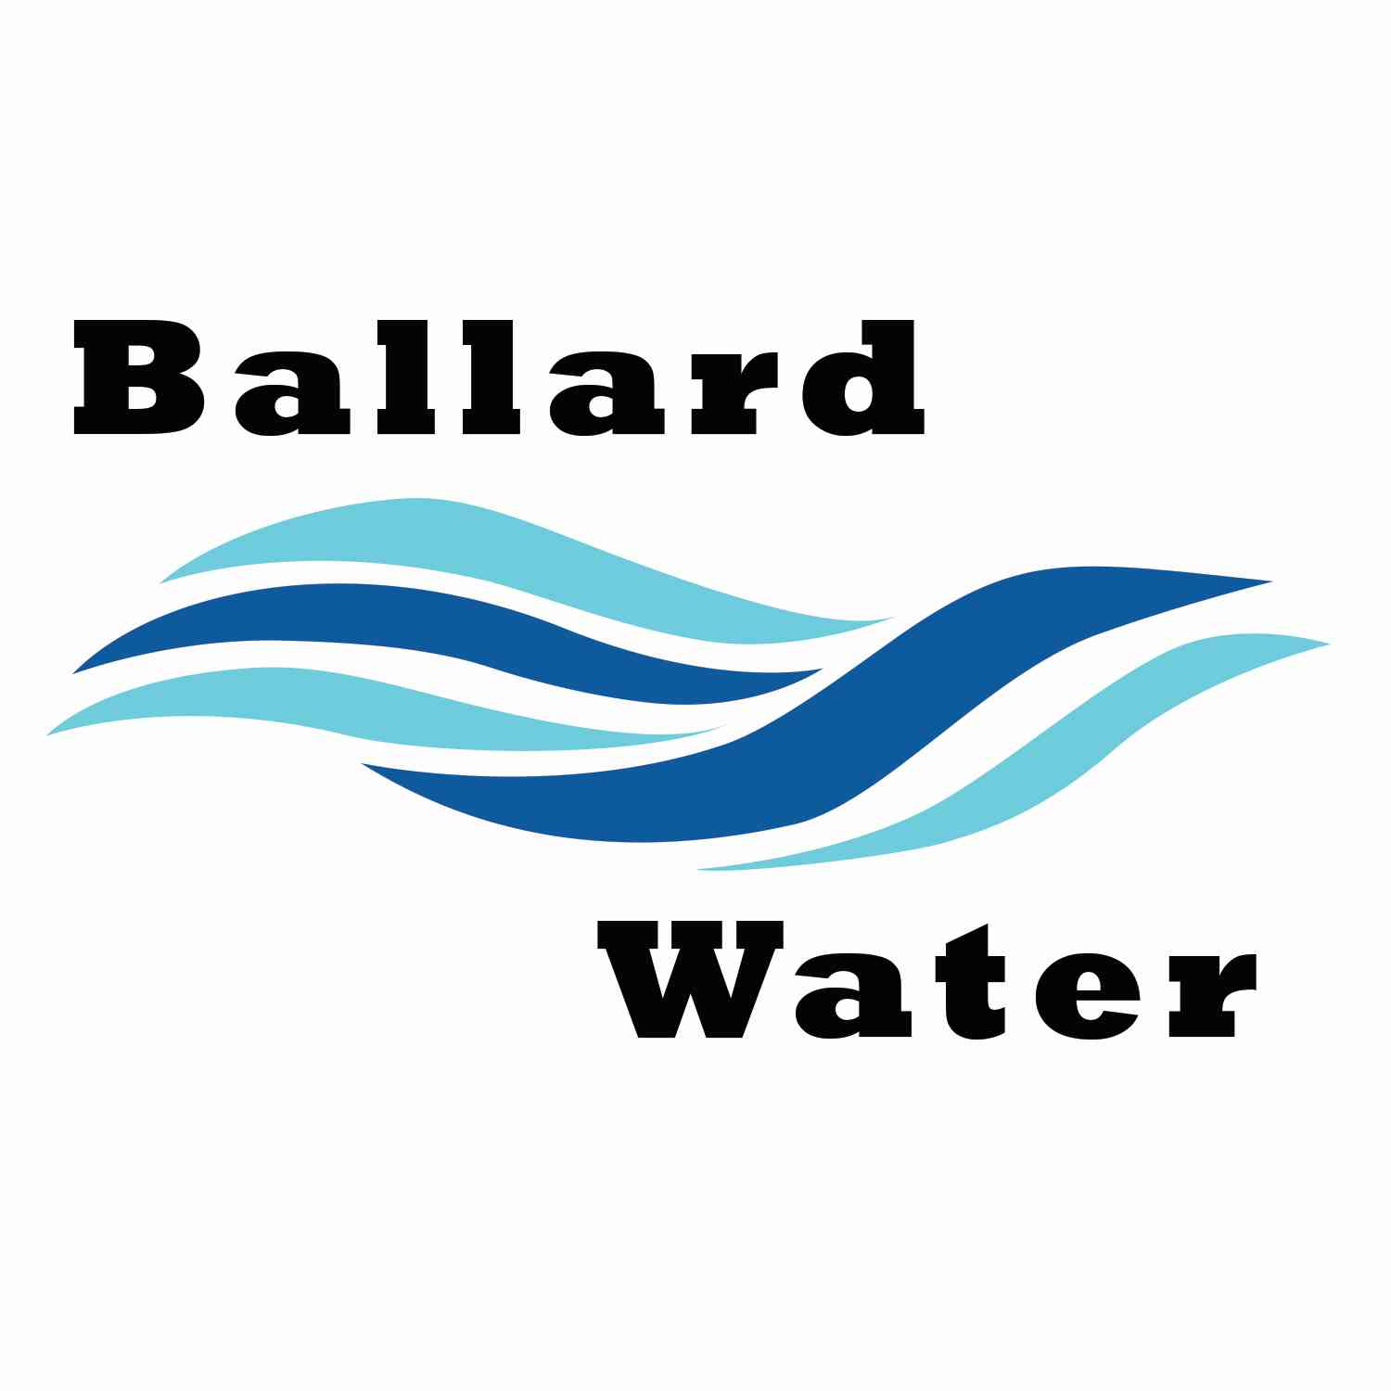

2381 E. 1000 S.

Ballard, UT 84066
Phone: (435) 722-3393
Email: amcdonald@ballardcity.org

Board Chairman

Mark Reidhead

Board Members

Bob Abercrombie

Andrew Ercanbrack

Ronny Rich

Jesse Danley

Visitors
Ryan Richens
Craig Nebeker
Linda Bowden
Mitchell Collett
Shaun Murray
Al Kettle

Water District Meeting

October 17, 2023, 5:30 pm

MINUTES

Item

CALL WATER BOARD MEETING TO ORDER

Welcome and Roll Call – Chairman Mark Reidhead welcomed all in attendance and called roll. Those in attendance are Board Members Bob Abercrombie, Andrew Ercanbrack, Jesse Danley, Secretaries Anissa McDonald, and Kaelyn Meyers. Board Member Ronny Rich was not in attendance at this meeting.

Prayer – Bob Abercrombie

Pledge of Allegiance- was said by all present.

- FIRE SUPPRESSION– Joe Archer
Mitch Collett was in attendance for Joe Archer to see if he can get water connections and was told that he needed to see if there is fire suppression on the subdivision just south of Hidden Valley. It was stated that on 3500 E. there is good fire flow. They would just need to make sure they put in a fire hydrant.
Mitch Collette will check with Joe Archer and to see if that is the property he is wondering about or if he has property in another area that doesn’t have fire suppression. Craig Nebeker stated that there should be plenty of fire suppression at that address and the model shows that there should be connections available. They are asking for a will serve letter for water including that a fire hydrant will have to be installed at that time.

- WATER CONNECTION – Joe & Linda Bowden
Linda Bowden explained that she is purchasing some property from Max Rasmusen. He explained that he still has some water hookups that can be used and that he has a letter explaining that no impact fee will be charged for him either.
Chairman Mark Reidhead explained that at the time of the letter (which he had a copy and was written in 2004), it stated at this time no impact would be charged. The minutes of July 2014 and again in Sept. 2018 it was decided that we would charge an impact for all certifications that are still not used. That includes the outstanding certifications that Max Rasmussen has.
It was stated that Joe & Linda Bowden would need to pay the impact fee for water hook-ups that were purchased prior to 2002. The cost would be $4200 per connection.

- FINAL BOND RESOLUTION FOR WATER REVENUE BONDS --
A RESOLUTION #102023-001 AUTHORIZING $3,600,000 TAXABLE WATER REVENUE BONDS, SERIES 2023, FOR THE PURPOSE OF FINANCING A PORTION OF THE COSTS OF WATER SYSTEM IMPROVEMENTS, AND RELATED INPROVEMENTS; AND RELATED MATTERS.
Motion was made by Board Member Bob Abercrombie to approve the Final Bond Resolution #102023-001 FOR Water Revenue Bonds, 2nd by Board Member Andrew Ercanbrack. All in favor.
Yea Nay
Board Members
Mark Reidhead
Bob Abercrombie
Andrew Ercanbrack
Jesse Danley
Board Member Ronny Rich was excused.

- RESOLUTION #2310-001 CANCELING WATER DISTRICT ELECTION–
Motion made by Board Member Jesse Danley, to cancel the Water Board Elections through Resolution 2310-001. 2nd by Board Member Robert Abercrombie. All in favor.
Yea Nay
Board Members
Mark Reidhead
Bob Abercrombie
Andrew Ercanbrack
Jesse Danley
Board Member Ronny Rich was excused.

- SEWER CONNECTION – Troy Gadd
Troy Gadd was not in attendance.

- ENGINEER PROJECT UPDATES –
Water Well Property Purchase -- The draft agreement to purchase property has been drawn up from Attorney Clark Allred for review. We will lease the property for 1 year until Dec. 20, 2024. This will be to drill a test well to see if this will be a good well. Project is moving forward and when getting started to drill should take about a month to get project bid and to get a contractor together. The test well and the construction of the final well will be projected in the same bid.
Water pipeline – Attorney Clark Allred stated that we need to have secured right of way for all pipe that is not in the road right-of-way throughout Ballard. We need to make sure all properties have a right-of-way.
Lead and copper project – This is progressing, and we have a year to get the inventory done.

- REVIEW & CORRECT MINUTES –
- September 19, 2023
Motion was made by Board Member Jesse Danley to approve the Minutes of September 19, 2023 as written. 2nd by Board Member Andrew Ercanbrack. All in favor.
Yea Nay
Board Members
Mark Reidhead
Bob Abercrombie
Andrew Ercanbrack
Jesse Danley
Board Member Ronny Rich was excused.

- FOLLOW-UP ON PAST MINUTES
The application for the Economic Opportunity grant came back with us not qualifying.

- FINANCES: Checks, Statements, Reports and Budget
Finances were gone over and approved.

- ADJOURN WATER BOARD MEETING

Motion was made by Board Member Andrew Ercanbrack to adjourn Water Board Meeting at 6:10 p.m. 2nd by Board Member Jesse Danley. All in favor.
Yea Nay
Board Members
Mark Reidhead
Bob Abercrombie
Andrew Ercanbrack
Jesse Danley
Board Member Ronny Rich was excused.

________________________________ ______________________
Chairman Mark Reidhead Date

________________________________ ______________________
Secretary Anissa McDonald Date

Approved Signed Copy filed in the Ballard City Offices

