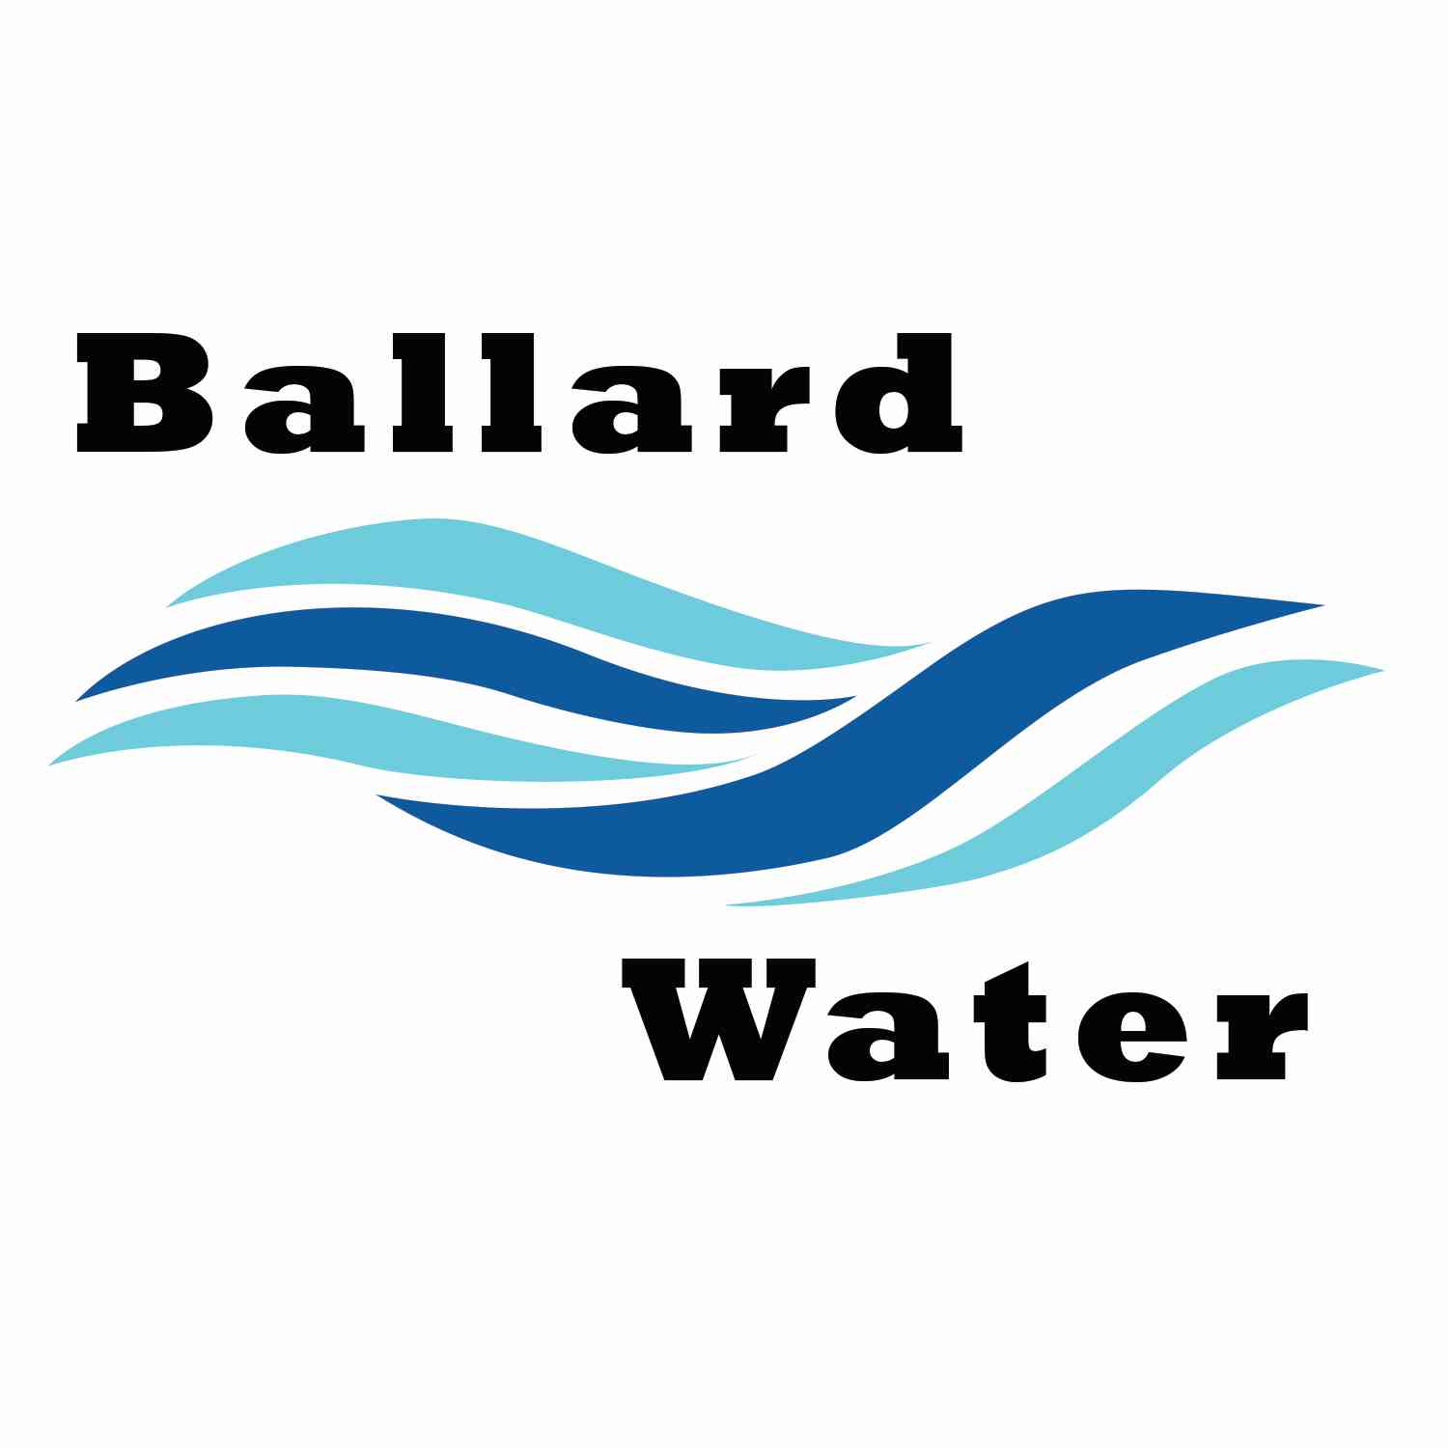

2381 E. 1000 S.

Ballard, UT 84066
Phone: (435) 722-3393
Email: amcdonald@ballardcity.org

Board Chairman

Mark Reidhead

Board Members

Bob Abercrombie

Andrew Ercanbrack

Ronny Rich

Jesse Danley

Visitors
Craig Nebeker
Jeffrey Baker
Al Kettle
Shaun Murray

Water District Meeting

November 21, 2023, 5:30 pm

MINUTES

Item

CALL WATER BOARD MEETING TO ORDER

Welcome and Roll Call – Chairman Mark Reidhead welcomed all in attendance and called roll. Those in attendance are Board Members Bob Abercrombie, Andrew Ercanbrack, Ronny Rich, Secretaries Anissa McDonald and Kaelyn Meyers. Board Member Jesse Danley was excused from the meeting.

Prayer – Andrew Ercanbrack

Pledge of Allegiance- was said by all present.

- WELL UPDATE –
Craig Nebeker stated that we have a plan to do the PDR’s for the Well Project and turn them into the state as soon as we can. The start of the drilling should commence in February. Monday, November 27, the well team will decide the best location for the well tank and other things related to the project. Jeff Baker stated that the agreement has been sent to the landowner and next week they will reach out to them and see if they agree to the terms. It should not take that much more time to get signatures. Chairman Mark Reidhead stated that we need to watch where the ditch is coming into the property. Jeff Baker suggested we investigate further and maybe use it as a waste ditch. Craig Nebeker asked if there is wet land up on that property. Jeff Baker stated that there might be. Craig Nebeker said all the reports have been received from the other wells in the area for Hydraulic details and they hope to review all of them.

- BUDGET REVIEW –
After a review of the 2024 Water District budget with no changes a public hearing will be scheduled for the December 19, meeting.
Motion was made by Board Member Bob Abercrombie to approve the 2024 Budget Worksheet as a tentative budget with the Public Budget Hearing set for the December 19, 2023 meeting. 2nd by Board Member Ronny Rich. All in favor.
Yea Nay
Board Members
Mark Reidhead
Bob Abercrombie
Andrew Ercanbrack
Ronny Rich
Board Member Jesse Danley was excused

- ENGINEER PROJECT UPDATES –
1500 E. Project – Craig Nebeker did some work with Ben Mower and identified possibly 3 areas in the city that does require a right of way for the 1500 E. Project. They will continue working on getting them.

Water Well Project – Jeff Baker stated that we have a letter of extension for 1 year from the Division of Drinking Water. This will help so we can work on getting the well drilled and other things done.

- REVIEW & CORRECT MINUTES –
- October 17, 2023
Motion was made by Board Member Andrew Ercanbrack to approve the Minutes of October 17, 2023 as corrected. 2nd by Board Member Bob Abercrombie. All in favor.
Yea Nay
Board Members
Mark Reidhead
Bob Abercrombie
Andrew Ercanbrack
Ronny Rich
Board Member Jesse Danley was excused

- FOLLOW-UP ON PAST MINUTES
Employee Christmas Bonus – Board Members discussed the Employee Christmas Bonus for this year. After a brief discussion, it was decided to let the City make the recommendation and we will put Bonuses on the December 19 agenda for a motion.

1500 E. North Water Line – Board Member Bob Abercrombie brought up that there are a couple of residents, one is building a home now and the other is paying tax on property for water from the district, on 1500 E. just past 1000 N. Currently we cannot furnish water to them and Roosevelt has put a moratorium on any more connections coming down from 2000 N. We really need to come up with a solution to get our water to homes in the area. It was decided that we initiate correspondence with Roosevelt to see what we can do to get water up to 2000 N. to our boundaries. Maybe even suggest that we loop it with their existing line coming down from Roosevelt.

- FINANCES: Checks, Statements, Reports and Budget
Finances were gone over and approved.

- ADJOURN WATER BOARD MEETING

Motion was made by Board Member Andrew Ercanbrack to adjourn Water Board Meeting at 6:30 p.m. 2nd by Board Member Ronny Rich. All in favor.
Yea Nay
Board Members
Mark Reidhead
Bob Abercrombie
Andrew Ercanbrack
Ronny Rich
Board Member Jesse Danley was excused.

_________________________________________ ________________________
Chairman Mark Reidhead Date

____________________________________ ________________________
Secretary Anissa McDonald Date

Approved Signed Copy filed in the Ballard City Offices

