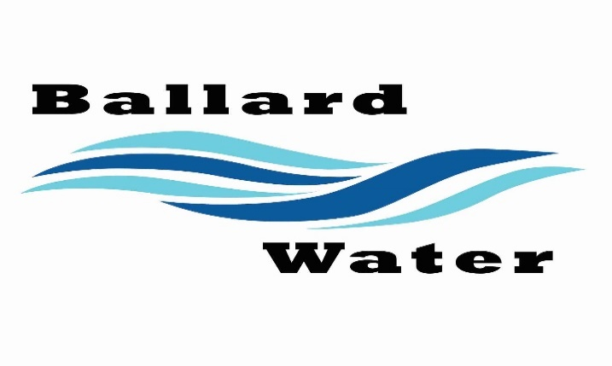

Board Chairman

Mark Reidhead

Board Members

Cory O’Driscoll

Andrew Ercanbrack

Ronny Rich

Jesse Danley

2381 E. 1000 S.

Ballard, UT 84066
Phone: (435) 722-3393
Email: amcdonald@ballardcityut.gov

Water District Meeting
Visitors
Rob McNeel
Craig Nebeker
Brock Harrison
Shaun Murray

May 20, 2025, 5:30 pm

MINUTES

Item

CALL WATER BOARD MEETING TO ORDER

Welcome and Roll Call – Chairman Mark Reidhead welcomed all in attendance and called roll. Those in attendance were Board Members Jesse Danley, Ronny Rich, Andrew Ercanbrack, and Secretaries Kaelyn Meyers and Anissa McDonald. Board Member Cory O’Driscoll was excused.

Prayer – Ronny Rich

Pledge of Allegiance- Was said by all in attendance.

- WATER CONNECTION – Wayne McMullin
Wayne McMullin was not in attendance.

- BALLARD SPRINGS CCR LETTER – Rob McNeel
Rob McNeel stated that he has some CCR’s that he can submit to the Board if that was what they needed to do. Ben Mower let him know that they would have to be approved at both the Water Board and the Council. They will cover everything regarding parking, and all the city requirements. It was stated that the district is worried about utilities only.

- BALLARD SPRING IMPACT FEE – Rob McNeel
Rob McNeel wondering about the cost of the impact fees. Ben Mower explained that Rob McNeel would like to see some discount with the cost of $8000.00 impact fees for each unit. Rob McNeel indicated that their contractor would like to do all the work with installing the meter and running the lines.
Craig Nebeker and Ben Mower have spoken a little to see what other cities do in a situation like this townhome project. Craig Nebeker said that what he has experienced with some of the districts, he has worked with only one district that will allow the contractor to install meter systems. Usually, the district will be the one to install the metering system to make sure it is done right. From the meter on the contractor takes over.
There is no policy regarding this situation, so Ben Mower asked Rob McNeel to come before the board. Rob McNeel explained that their excavators usually put them in and they would pay for the inspectors as the project went along. Ben Mower explained that we don’t have the manpower to come and inspect each meter going in. He would like to see the meters installed inhouse.
Chairman Mark Reidhead asked how many meters will be going in. Ben Mower stated that there is one for every building that is proposed. Rob McNeel explained that each building will have their own parcel number and so he feels that they each need their own meter system. They will only be doing two buildings with 8 units per phase. They are planning to run lines with each phase to each building. The first two buildings will be about 300 feet of line. He is looking at approximately 3 years to complete the phases. Phase one will include a fire hydrant.
Chairman Mark Reidhead stated that the connection fee could be minimal if they do the work, and they would have to use our engineers for inspection. The impact fee would stay the same at $4200 per connection. Rob McNeel would like to see us reduce the price on the impact fee also. It seems that Roosevelt and Vernal both are lower. It was stated that our fee is only $1200 different from Roosevelt City. It was stated that we lower the meter connection fee to $350.00 per unit because we have to purchase the equipment that they will set.
Craig Nebeker stated that he has just completed a study for Vernal city because they need to adjust their impact fees to a higher cost. Ben Mower stated that with Vernal, they are looking at thousands of connections where we only have a few residents, and the townhouses will have a greater impact the system.
Motion made by Board Member Andrew Ercanbrack to lower the connection fee to $350 per unit with using our engineers as inspectors and keep the impact fee at $4200.00 per unit for the townhome projects. 2nd by Board Member Ronny Rich. All in favor.
YEA NAY
Board Members
Jesse Danley
Ronny Rich
Andrew Ercanbrack
Mark Reidhead
Board Member Cory O’Driscoll was excused.

- BALLARD SPRINGS SEWER CONNECTIONS – Rob McNeel
Ben Mower stated that for both the sewer connection and impact fee would be $3000 per connection. Casey an associate of Rob McNeel asked if in putting the sewer line, do they have to go back to the manhole with each phase. Ben Mower stated yes they will.

- ENGINEERING UPDATE –
Upper System Water Line Project -- Brock Erickson with Jones & DeMille gave update on upper system well, tank and water line project. The project will change to be a transmission project up around Montez creek area. Brock Erickson stated that their assessment was that there was a drop in pressure around 3000 N. After modeling that area, what is causing those pressure issues is what is coming from the tribe system.
There is still out initial funding package for this project and there is some lines that we should address with what is left. Instead of coming along 4000 S and dropping down, they are looking only replacing the 3500 E. and coming south to the tank to upsize those old pipes. The cost proposed includes the cost for the well. This would be a marginal improvement for residents up by Ronny Rich.
Motion was made by Board Member Ronny Rich to approve the Ballard Water scope change on the Upper System Water Line Project as presented by Jones & DeMille. 2nd by Jesse Danley.
YEA NAY
Board Members
Jesse Danley
Ronny Rich
Andrew Ercanbrack
Mark Reidhead
Board Member Cory O’Driscoll was excused.

1500 E. Roadway Project – Ben Mower stated that there is some water line problems going East toward Roosevelt on 1000 S. There is about 300 feet of line that we would be wise to upgrade. The mayor indicated to Ben Mower that the City project might cover the project cost and the District would have to cover the materials. This is the best time to upgrade this line by doing the project together.

- REVIEW & CORRECT MINUTES –
- April 15, 2025
Motion made by Board Member Jesse Danley to approve the minutes of April 15, 2025 as written, 2nd by Board Member Andrew Ercanbrack. All in favor.
YEA NAY
Board Members
Jesse Danley
Ronny Rich
Andrew Ercanbrack
Mark Reidhead
Board Member Cory O’Driscoll was excused.

- FOLLOW-UP ON PAST MINUTES –
Nothing followed up on.

- FINANCES: Checks, Statements, Reports and Budget
Checks and finances were gone over and approved.

- ADJOURN WATER BOARD MEETING
Motion made by Board Member Andrew Ercanbrack to adjourn Water Board Meeting at 7 p.m., 2nd by Board Member Ronny Rich. All in favor.
YEA NAY
Board Members
Jesse Danley
Ronny Rich
Andrew Ercanbrack
Cory O’Driscoll
Mark Reidhead

Chairman Mark Reidhead Date

Secretary Anissa McDonald Date

