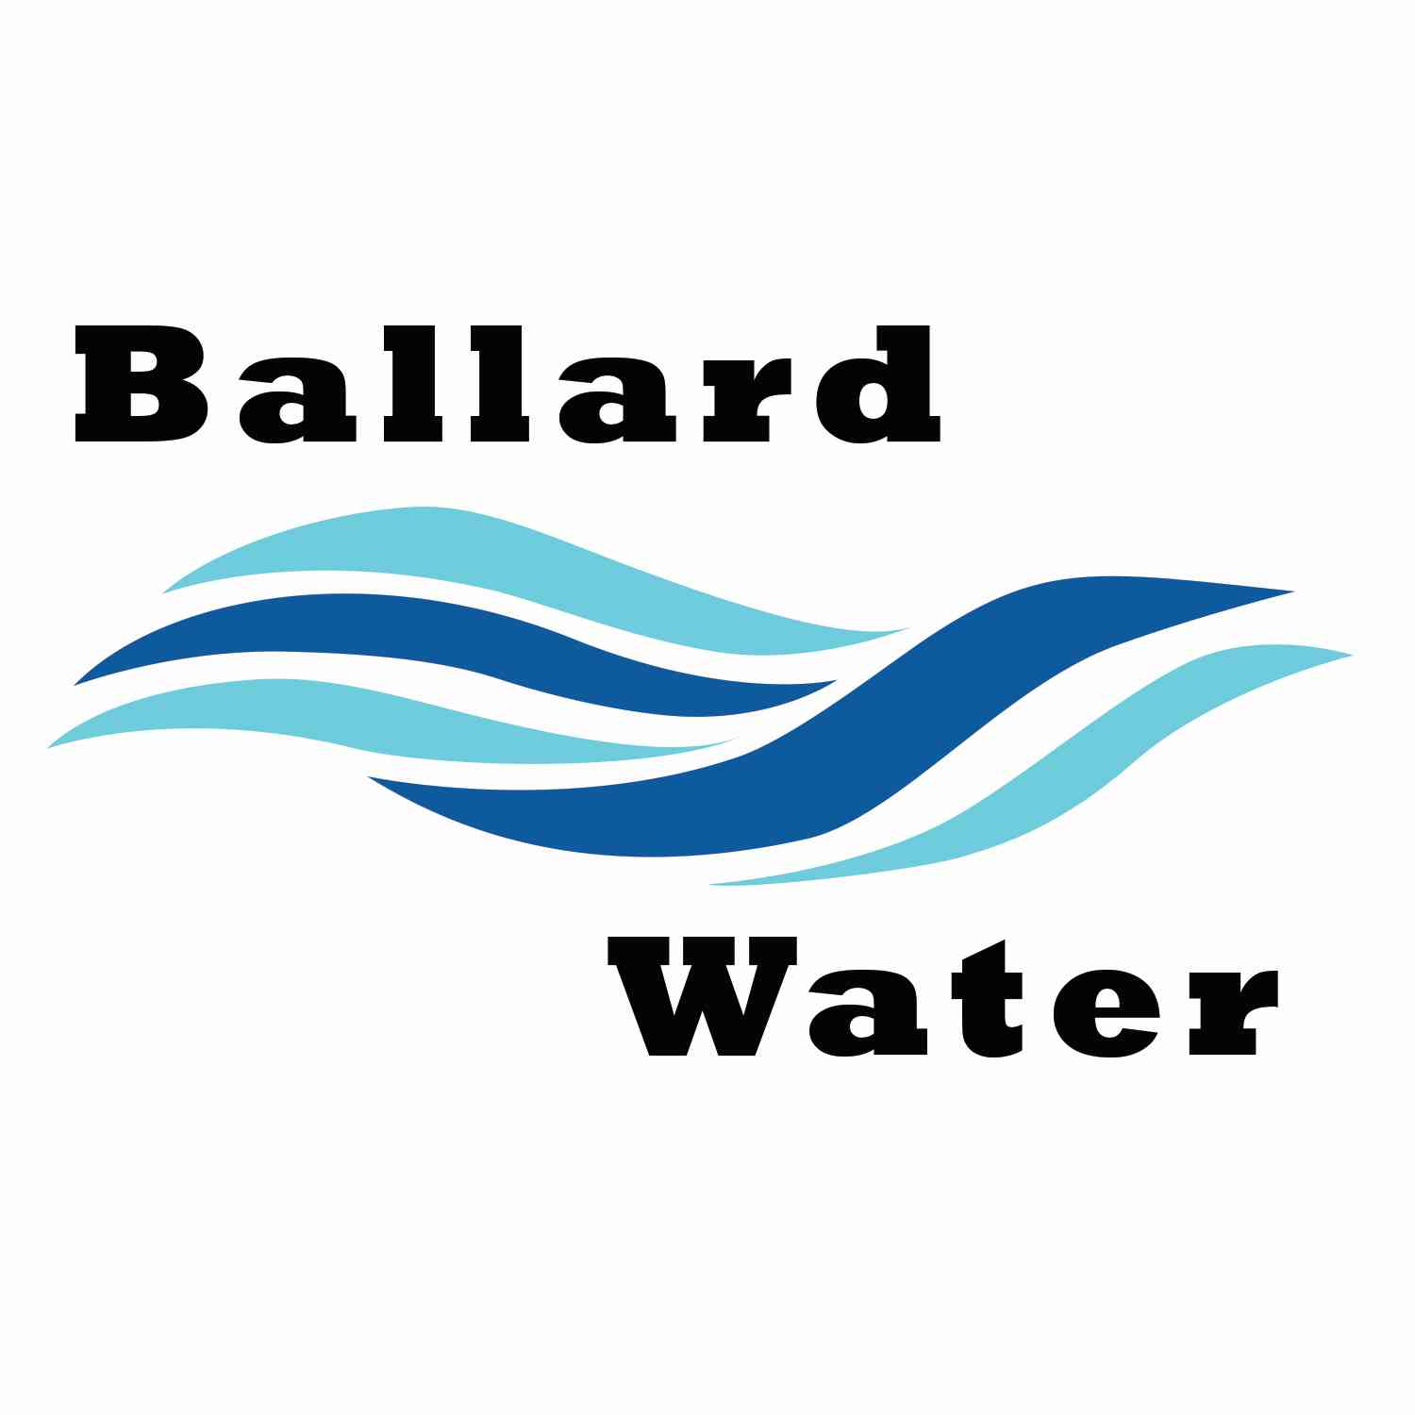

Water District Meeting

Board Chairman

Mark Reidhead

Board Members

Cory O’Driscoll

Andrew Ercanbrack

Ronny Rich

Jesse Danley

MAY 21, 2024, 5:30 pm

2381 E. 1000 S.

Ballard, UT 84066
Phone: (435) 722-3393
Email: amcdonald@ballardcity.org

MINUTES

Water District Meeting
Visitors
Marilyn Duncan
Al Kettle
Clegg Batty
Craig Nebeker
Shaun Murray
Don Richards

May 21, 2024, 5:30 pm
MEETING

Item

CALL WATER BOARD MEETING TO ORDER

Welcome and Roll Call – Chairman Mark Reidhead welcomed all in attendance and called roll. Those in attendance were Board Members Andrew Ercanbrack, Ronny Rich, Secretary Kaelyn Meyers. Board Members Cory O’Driscoll and Jesse Danley were excused.

Prayer – Mark Reidhead

Pledge of Allegiance- Said by all in attendance.

- WATER LEAK/BILL – Joyce Eldredge
Joyce Eldredge explained that she had a water leak in her back yard. They turned the water off when they noticed it. She is wondering if the district can reduce what she owes. After a brief discussion as to what we do in the past, it was decided to reduce it to the minimum of $394.00.
Motion made by Board Member Andrew Ercanbrack to adjust water bill for Joyce Eldredge to $394.00, 2nd by Board Member Ronny Rich. All in favor.
YEA NAY
Board Members
Mark Reidhead
Ronny Rich
Andrew Ercanbrack
Board Members Jesse Danley and Cory O’Driscoll was excused

- UINTAH COUNTY TAX RATE APPROVAL–
Motion made by Board Member Ronny Rich to approve the Uintah County Tax Rate as .00388 for 2025, 2nd by Board Member Andrew Ercanbrack. All in favor.
YEA NAY
Board Members
Mark Reidhead
Ronny Rich
Andrew Ercanbrack
Board Members Jesse Danley and Cory O’Driscoll was excused

- A RESOLUTION AMENDING THE REPAYMENT SCHEDULE ON THE $3,600,000 TAXABLE WATER REVENUE BONDS, SERIES 2024; AND RELATED MATTERS – WELL PROJECT BID AWARD
Chairman Mark Reidhead explained that they are amending the repayment schedule because of how long it is taking to start the project. This will delay the 1st payment due to January 2026.
Motion made by Board Member Ronny Rich to approve the Ballard Water Taxable Water Revenue Bonds series 2024 amending Resolution, 2nd by Board Member Andrew Ercanbrack. All in favor.
YEA NAY
Board Members
Mark Reidhead
Ronny Rich
Andrew Ercanbrack
Board Members Jesse Danley and Cory O’Driscoll was excused

- WELL PROJECT BID AWARD –
The bid opening for the Water Well project was conducted on June 13, 2024. There were two bids that met the criteria for the project. The engineer’s estimate for the project was $607,688.50. The bid from Cluff Drilling and Pump was $687,703.20. The bid from Lamb Drilling was $912,227.00. Engineers called references for Cluff Drilling and are confident that they are experienced drillers and can perform the work.
Motion made by Andrew Ercanbrack to award the bid to Cluff Drillers in the amount of $687,703.80, 2nd by Board Member Ronny Rich. All in favor.
YEA NAY
Board Members
Mark Reidhead
Ronny Rich
Andrew Ercanbrack
Board Members Jesse Danley and Cory O’Driscoll was excused

- ENGINEER PROJECT UPDATES –
Well Project – it should take 90 days for us to be done with the drilling of the well. We just need to find the water that we are looking for. Army Corp is still working with the remediation survey getting done.
Copper & Lead Project – Ben Mower stated that we are working on an app that will help with the GIS system. This will allow us to link the information with our existing GIS system.

- EMPLOYEE RAISES –
Chairman Mark Reidhead went over the employees raises and noted what the raise would be for 2, 3, 4, and 5%. It was decided that the employees receive a 5% raise between the Water District and City.
Motion made by Board Member Ronny Rich to approve employee raise of 5% to be split between Water Board and the City, 2nd by Board Member Andrew Ercanbrack. All in favor.
YEA NAY
Board Members
Mark Reidhead
Ronny Rich
Andrew Ercanbrack
Board Members Jesse Danley and Cory O’Driscoll was excused

- REVIEW & CORRECT MINUTES –
- May 21, 2024
Motion made by Board Member Andrew Ercanbrack to approve the minutes of May 21, 2024 as corrected. 2nd by Board Member Ronny Rich. All in favor.
YEA NAY
Board Members
Mark Reidhead
Ronny Rich
Andrew Ercanbrack
Board Members Jesse Danley and Cory O’Driscoll was excused

- FOLLOW-UP ON PAST MINUTES
Nothing to follow up on.

- FINANCES: Checks, Statements, Reports and Budget
Checks and finances were gone over and approved.

- ADJOURN WATER BOARD MEETING
Motion made by Board Member Andrew Ercanbrack to adjourn Water Board Meeting at 6:10 p.m. 2nd by Board Member Ronny Rich. All in favor.
YEA NAY
Board Members
Mark Reidhead
Ronny Rich
Andrew Ercanbrack
Board Members Jesse Danley and Cory O’Driscoll was excused

___
Chairman Mark Reidhead Date

_________
Secretary Anissa McDonald Date

