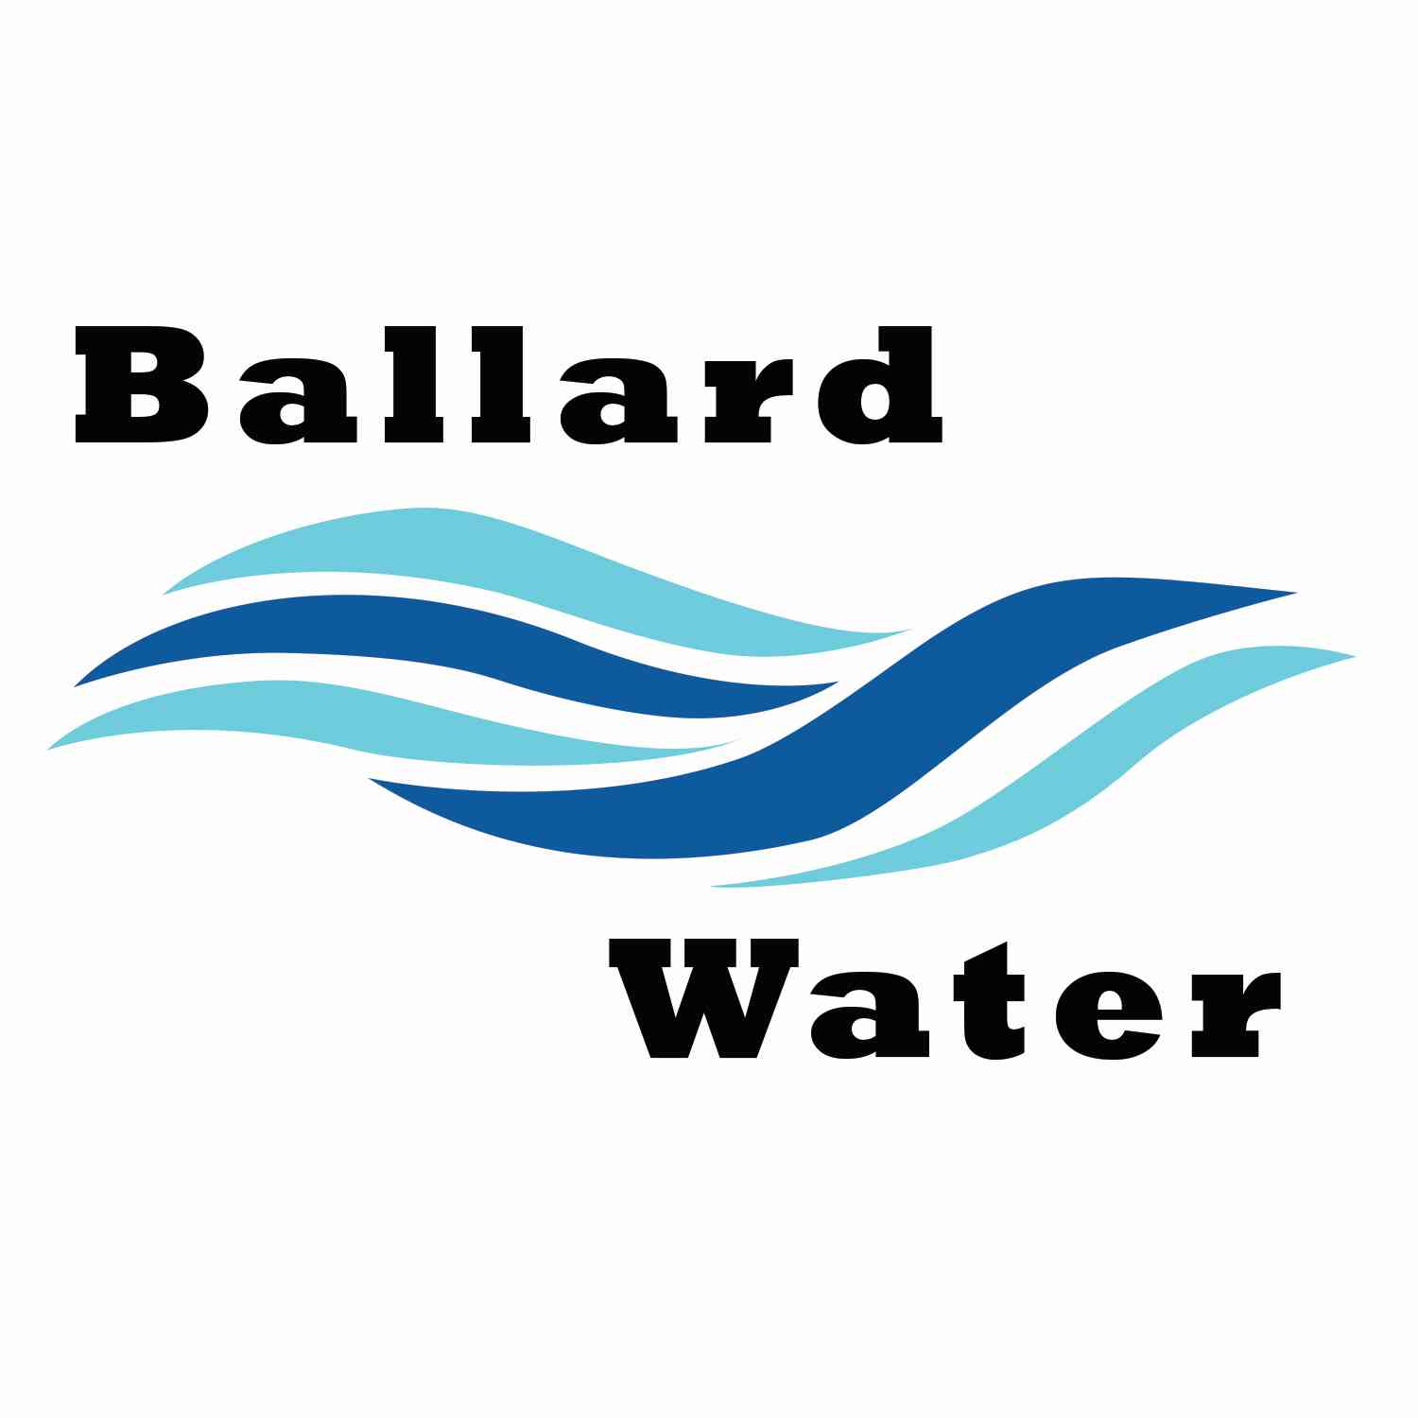

2381 E. 1000 S.

Ballard, UT 84066
Phone: (435) 722-3393
Email: amcdonald@ballardcity.org

Board Chairman

Mark Reidhead

Board Members

Cory O’Driscoll

Andrew Ercanbrack

Ronny Rich

Jesse Danley

Visitors
Craig Nebeker
Mark Jensen
Al Kettle

Water District Meeting

JULY 16, 2024, 5:30 pm

MINUTES

Item

CALL WATER BOARD MEETING TO ORDER

Welcome and Roll Call – Chairman Mark Reidhead welcomed all in attendance and called roll. Those in attendance were Board Members Cory O’Driscoll, Andrew Ercanbrack, Jesse Danley and Secretary Kaelyn Meyers. Board Member Ronny Rich was excused.

Prayer – Cory O’Driscoll

Pledge of Allegiance- was said by all present.

- ENGINEER PROJECT UPDATES –
Water Well Project – Craig Nebeker from CRS Engineering gave an update for the well. They will start drilling August 1 with prep work done prior.
Lead and Copper Project – Ben Mower has been trained on the GIS information that he will be using to log into the system and generate the state reports.
Merger – Craig Nebeker explained that CRS Engineers will be merging with Horrocks Engineering. They will be adding services to each company and will be able to offer more to the companies that currently have contracts through. For Ballard Water, there will be no changes in who we work with. CRS will take on the Horrocks name.

- REVIEW & CORRECT MINUTES –
- June 18, 2024
Deferred June 18, 2024 minutes

- FOLLOW-UP ON PAST MINUTES
No follow-up

- FINANCES: Checks, Statements, Reports and Budget
Checks and finances were gone over and approved.

- ADJOURN WATER BOARD MEETING
Motion was made by Board Member Jesse Danley to adjourn meeting at 5:45 p.m. 2nd by Board Member Cory O’Driscoll. All in favor.
Yea Nay
Board Members
Mark Reidhead
Andrew Ercanbrack
Cory O’Driscoll
Jesse Danley

Board Member Ronny Rich was excused.

______________________________ _______________________
Chairman Mark Reidhead Date

______________________________ _______________________
Secretary Anissa McDonald Date

