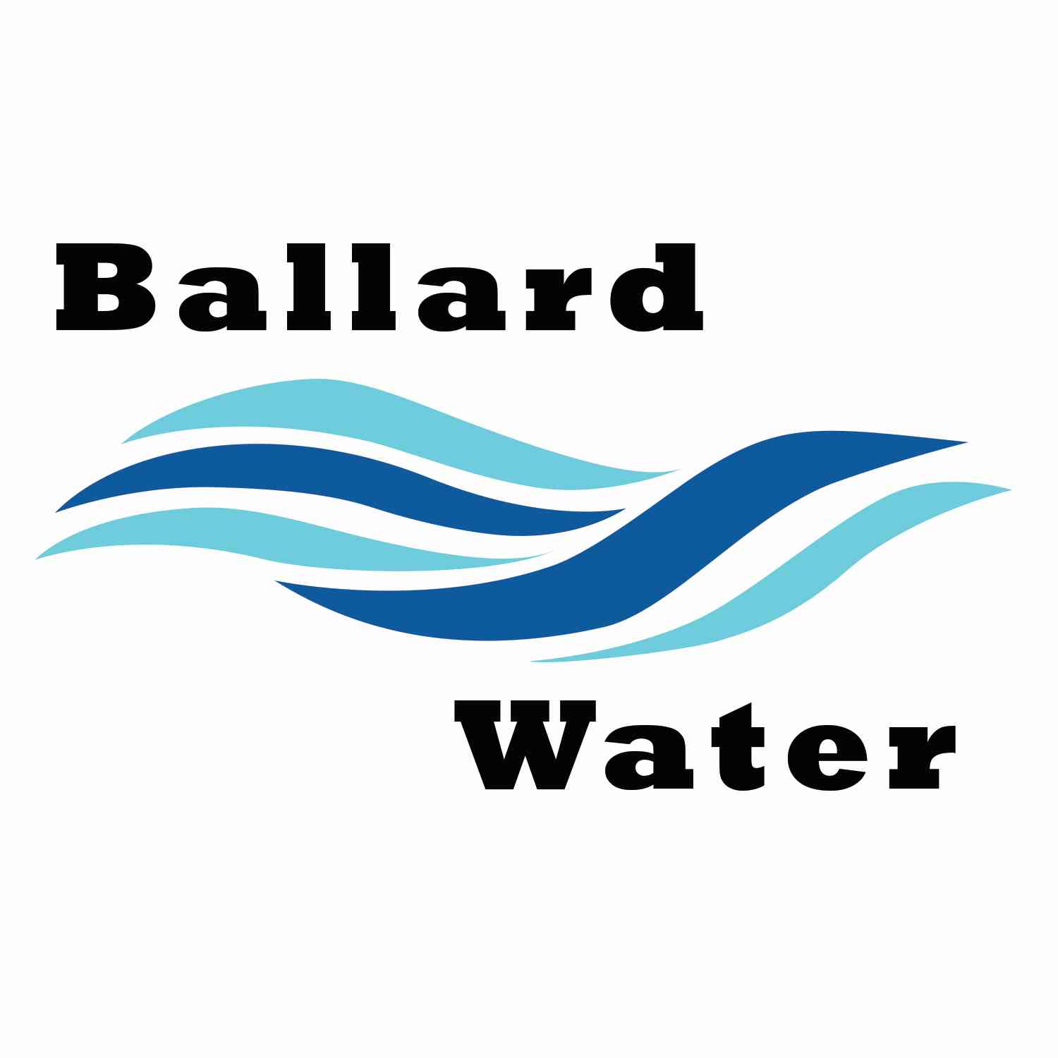

2381 E. 1000 S.

Ballard, UT 84066
Phone: (435) 722-3393
Email: amcdonald@ballardcity.org

Board Chairman

Mark Reidhead

Board Members

Cory O’Driscoll

Andrew Ercanbrack

Ronny Rich

Jesse Danley

Visitors
Ryan Richens
Shawn Wilkins
Walter Bagley
Andrea Bagley
Shaun Murray

Water District Meeting

January 16, 2024, 5:30 pm

MINUTES

Item

CALL WATER BOARD MEETING TO ORDER

Welcome and Roll Call – Chairman Mark Reidhead welcomed all in attendance and called roll. Those in attendance were Board Members Cory O’Driscoll, Ronny Rich, Jesse Danley, Andrew Ercanbrack, Secretaries Anissa McDonald, and Kaelyn Meyers.

Prayer – Jesse Danley

Pledge of Allegiance- Said by all in attendance.

- BOARD MEMBER APPOINTMENTS –
Board Member Andrew Ercanbrack and Board Member Cory O’Driscoll were given the oath of office and welcomed to the Water Board.

- CHAIRMAN APPOINTMENT—
Motion made by Board Member Ronny Rich to nominate Mark Reidhead as the 2024 Waterboard Chairman, 2nd by Board Member Jesse Danley. All in favor.
YEA NAY
Board Members
Jesse Danley
Ronny Rich
Andrew Ercanbrack
Cory O’Driscoll
Mark Reidhead

- WATER LEASE AGREEMENT- Shawn Wilkins
Shawn Wilkins stated that this is the last year for the current water lease agreement, and he expressed interest in leasing again for the next 5 years. Chairman Mark Reidhead said that we will need to put this on the calendar for the 1st of January in 2025 along with putting a notice in the paper for those interested in putting in a bid. At that time another agreement will be signed with Dry Gulch.

- ENGINEER PROJECT UPDATES –
TANK AND WELL PROJECT -- Ryan Richens with CRS Engineers gave an update for the well and tank. Property descriptions have been put together for the easements that will be needed. They are working with Clark Allred for those easements. Division of Drinking water has until the end of February to let us know on the well. Test drilling will take place around the first part of May.

LEAD AND COPPER PROJECT -- Regarding the lead and copper revision Ryan said that they are currently mapping the water that will be affected.

RURAL WATER CONFERENCT -- Rural Water Conference will be attended this year by CRS. Chairman Mark Reidhead asked the board if anyone wanted to go to the conference this year, if so, he said to talk to Secretary Anissa McDonald and she will help get a room and schedule the conference. He stated that they would need to attend the classes and bring back any information that seemed to benefit the city. He explained the mileage and per-diem that they would receive.

- PUBLIC MEETINGS TRAINING –
Every year training is required and so we will schedule the Public Meetings Training for the next meeting on February 20, 2024

- REVIEW & CORRECT MINUTES –
- December 19, 2023
Motion made by Board Member Jesse Danley to approve the minutes of December 19, 2023, as corrected. 2nd by Board Member Cory O’Driscoll. All in favor.
YEA NAY
Board Members
Jesse Danley
Ronny Rich
Andrew Ercanbrack
Cory O’Driscoll
Mark Reidhead

- FOLLOW-UP ON PAST MINUTES
No follow-up at this time.

- FINANCES: Checks, Statements, Reports and Budget
Checks and finances were gone over and approved.

- ADJOURN WATER BOARD MEETING
Motion made by Board Member Andrew Ercanbrack to adjourn at 6 p.m. 2nd by Board Member Jesse Danley. All in favor.
YEA NAY
Board Members
Jesse Danley
Ronny Rich
Andrew Ercanbrack
Cory O’Driscoll
Mark Reidhead

Chairman Mark Reidhead Date

Secretary Anissa McDonald Date

