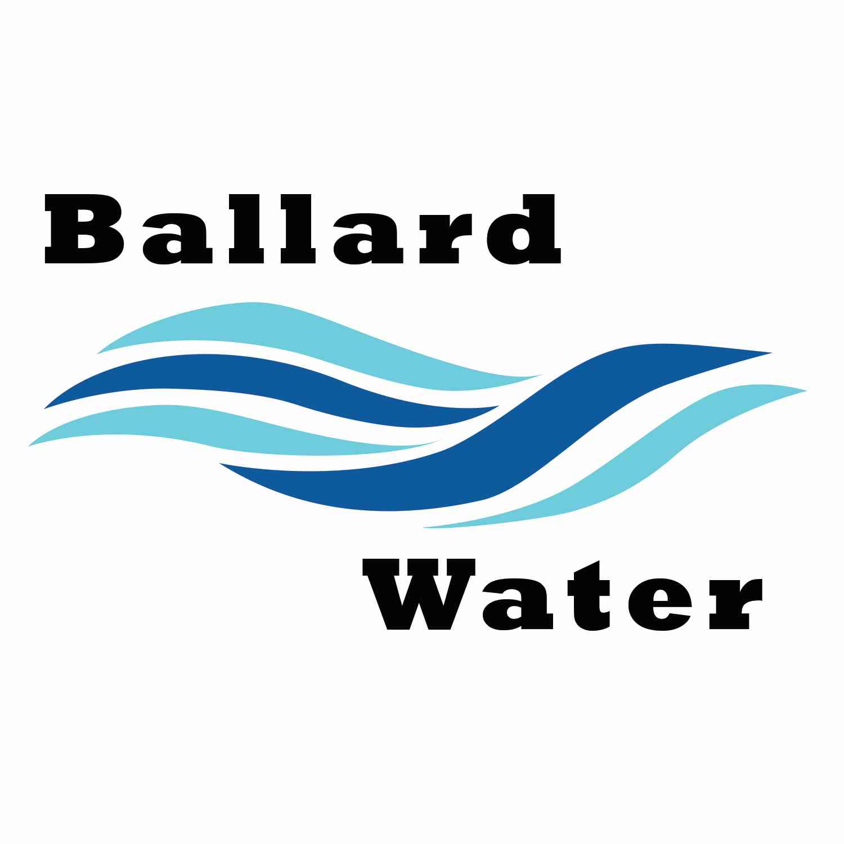

2381 E. 1000 S.

Ballard, UT 84066
Phone: (435) 722-3393
Email: amcdonald@ballardcity.org

Board Chairman

Mark Reidhead

Board Members

Cory O’Driscoll

Andrew Ercanbrack

Ronny Rich

Jesse Danley

Water District Meeting
Visitors
Matthew Harris
Cable Murray
Craig Nebeker
Jeffrey Baker
Al Kettle
Dan Mortensen

February 20, 2024, 5:30 pm

MINUTES

Item

CALL WATER BOARD MEETING TO ORDER

Welcome and Roll Call – Chairman Mark Reidhead welcomed all in attendance and called roll. Those in attendance were Board Members Cory O’Driscoll, Ronny Rich, Jesse Danley, Andrew Ercanbrack, Secretaries Anissa McDonald, and Kaelyn Meyers.

Prayer – Cory O’Driscoll

Pledge of Allegiance- Said by all in attendance.

- COMMERCIAL WATER & SEWER CONNECTION – Cable Murray
Mathew Harris presented a plan for Taco Fiesta and presented a preliminary design to put a restaurant just east of 3500 E. They need to speak to us regarding the sewer and water in that area. It was stated that there are two options for water. They could come off the highway or they can come off of 3500 E. Another area of concern will be the fire hydrant. Mathew Harris presented his findings on how much water they would expect to use as a commercial restaurant.
After a discussion regarding the access to water and which way to run the line, Chairman Mark Reidhead stated that they can go through Ben Mower for future options as well as deciding which way they want to proceed.
Engineer Craig Nebeker will run about 4,000 gallons a day for the model to see where we stand. The board indicated that a restaurant is a good idea for that area.

- PCIF CAPITAL IMPROVEMENT 1 YR, 5 YR LIST —
The one- and 2-5-year PCIF capital Improvement List was gone over with changes made to both. It was decided that we keep only one item on the 1-year list and move the other items to the 2–5-year list.

- FRAUD RISK ASSESSMENT -
Chairman Mark Reidhead read the Fraud Risk Assessment as presented.
Motion was made by Board Member Ronny Rich to approve the 2024 Fraud Risk Assessment. 2nd by Board Member Andrew Ercanbrack.
Yea Nay
Council Members
Mark Reidhead
Cory O’Driscoll
Andrew Ercanbrack
Ronny Rich
Jesse Danley

- ENGINEER PROJECT UPDATES –
TREE REMOVAL 1500 E. PROJECT – Jeff Baker explained that there was a bid opening for tree removal along 1500 E. for the City Road Project that will commence soon.

TANK AND WELL PROJECT – It was decided that CRS, and Jones & DeMille along with Ben Mower and whoever wants to be included, that a reoccurring meeting be set up, possibly on Friday’s and at lease a couple of times a month for the well project. The project status is, CRS has the preliminary project report for the state ready to go. The neighbor to the east or Zone 2, which the line will travel through is dragging their feet in signing with the state and wants the contract to state that no chemicals will be put into or contaminate the land. The engineers are looking at all possibilities. The engineers are also looking into putting in an application for water rights for the exploratory well from the Division Of Water Rights. A Cultural survey still needs to be done for the area. They are hoping for March but might be April for bidding out for the well driller.

LEAD AND COPPER PROJECT – Craig Nebeker updated the board regarding the Lead and copper project. Some of the meters aren’t being read that they are working on. They are also trying to narrow down the years before 1991 that will have more of the issues to be addressed. This project is due to be done by October 16 of this year.

- PUBLIC MEETINGS TRAINING –
Board Members watched the Public Meetings Training that is required each year.
Those in attendance include Chairman Mark Reidhead, Board Members Cory O’Driscoll, Andrew Ercanbrack, Ronny Rich, Jesse Danley, secretaries Anissa McDonald and Kaelyn Meyers.

- REVIEW & CORRECT MINUTES –
- January 16, 2024
Motion made by Board Member Jesse Danley to approve the minutes of January 16, 2024, as corrected. 2nd by Board Member Ronny Rich. All in favor.
Yea Nay
Council Members
Mark Reidhead
Cory O’Driscoll
Andrew Ercanbrack
Ronny Rich
Jesse Danley

- FOLLOW-UP ON PAST MINUTES
No follow-up at this time.

- FINANCES: Checks, Statements, Reports and Budget
Checks and finances were gone over and approved.

- ADJOURN WATER BOARD MEETING
Motion made by Board Member Andrew Ercanbrack to adjourn Water Board Meeting at 6:50 p.m. 2nd by Board Member Jesse Danley. All in favor.
Yea Nay
Council Members
Mark Reidhead
Cory O’Driscoll
Andrew Ercanbrack
Ronny Rich
Jesse Danley

Chairman Mark Reidhead Date

Secretary Anissa McDonald Date

