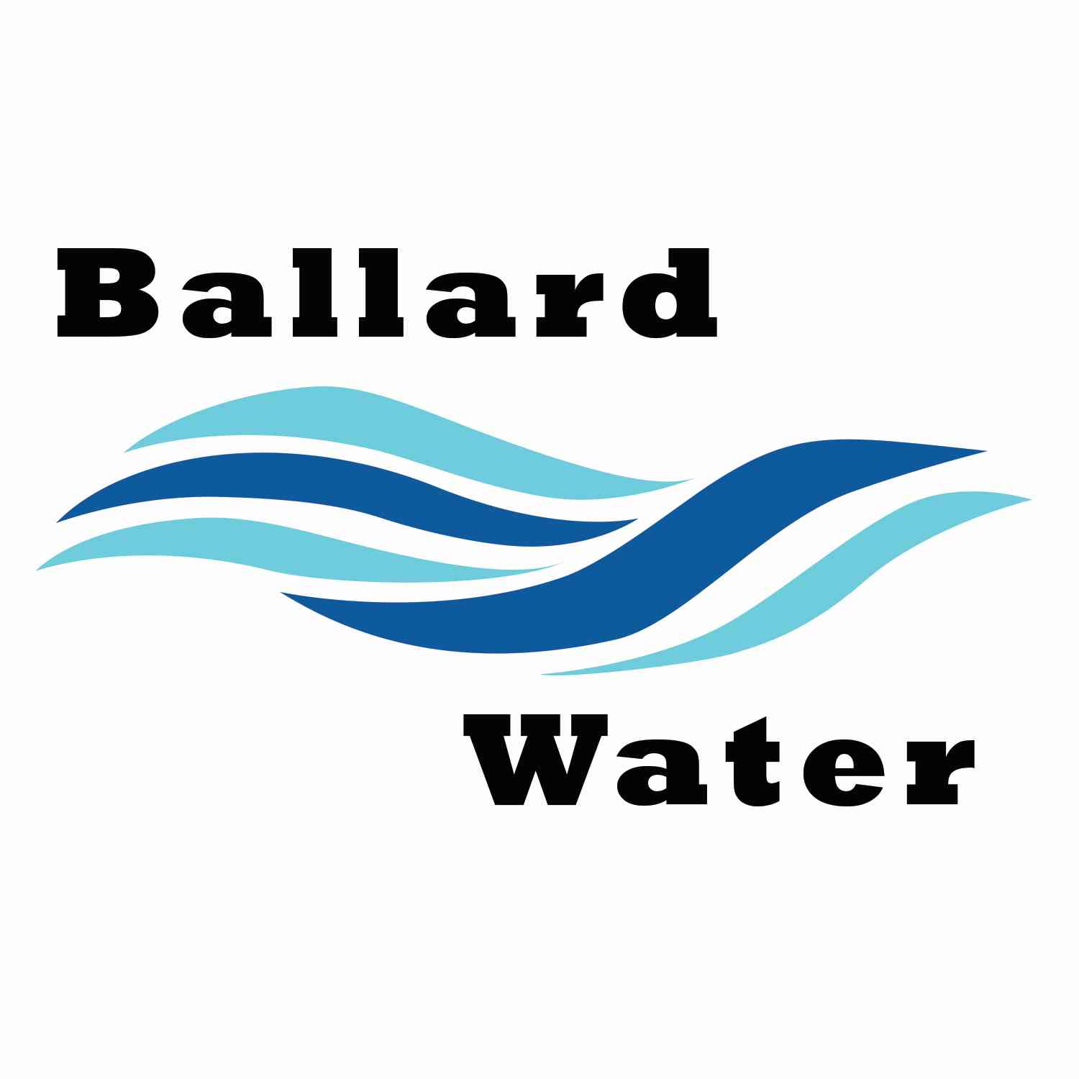

Board Chairman

Mark Reidhead

Board Members

Bob Abercrombie

Andrew Ercanbrack

Ronny Rich

Jesse Danley

2381 E. 1000 S.

Ballard, UT 84066
Phone: (435) 722-3393
Email: amcdonald@ballardcity.org

Visitors
Craig Nebeker
Cory O’Driscoll
Jeffrey Baker

Water District Meeting

December 19, 2023, 5:30 pm

MINUTES

Item

CALL WATER BOARD MEETING TO ORDER

Welcome and Roll Call – Chairman Mark Reidhead welcomed all in attendance and called roll. Those in attendance include Board Members Bob Abercrombie, Andrew Ercanbrack, Ronny Rich, Jesse Danley, and Secretary Kaelyn Meyers. Secretary Anissa McDonald was excused from the meeting.

Prayer – Ronny Rich

Pledge of Allegiance- was said by all present.

- WELL UPDATE –
Chairman Mark Reidhead updated the board on the Well Project. He stated that last Monday we signed papers on the well site. We will start forward with well drilling. Engineer Jeff Baker stated that there are quite a few wetlands in the area, and someone will be coming out to see if there are any areas that we can rule out.
Engineer Craig Nebeker stated that the finalizing of the Preliminary well report is progressing. This will be submitted to the Division of Drinking Water by the end of January or beginning of February. Specifications for the well need to be approved by the Division of Drinking Water.
Craig Nebeker stated that the rights-of-way in that area are still being worked on.

- BUDGET HEARING -- 6:00 p.m.
Motion was made by Board Member Bob Abercrombie to go out our regular Water Board Meeting and open our Public Hearing at 5:55 p.m. 2nd by Board Member Jesse Danley. All in favor.
Yea Nay
Board Members
Mark Reidhead
Bob Abercrombie
Andrew Ercanbrack
Ronny Rich
Jesse Danley
Review of the 2024 Budget was made with no public comments and no changes.
Motion was made by Board Member Jesse Danley to close our Public Hearing and go back into the regular meeting at 6:05 p.m. 2nd by Board Member Andrew Ercanbrack. All in favor.
Yea Nay
Board Members
Mark Reidhead
Bob Abercrombie
Andrew Ercanbrack
Ronny Rich
Jesse Danley
Motion was made by Board Member Jesse Danley to approve the 2024 Water District Budget as presented. 2nd by Board Member Andrew Ercanbrack. All in favor.
Yea Nay
Board Members
Mark Reidhead
Bob Abercrombie
Andrew Ercanbrack
Ronny Rich
Jesse Danley

- LEAD & COPPER ENGINEERING CONTRACT – CRS
Engineer Craig Nebeker stated that another government project we have going is regarding the lead and copper inventory that needs to be done. This is the proposal that CRS has come up with. We are supposed to report which resident, business or school has lead piping between the main line and the building. Deadline is Oct 16, 2024. We have been approved for a grant of about $85,000 that will be helpful in accomplishing this. CRS will build an app to collect the field data with each service connection and what type of line is used. Historical records will be looked at to help determine the construction date. Anything before 1991 needs to be especially reviewed. Along with service line, they will be collecting data on all residents’ private lines through a survey or letter, especially on the pre 1991 lines. To hit the deadline, we will need to start in the spring. This will take approximately 3 good months to accomplish. Proposal will be $37,300.00 from CRS.
Motion made by Board Member Bob Abercrombie to approve the CRS contract for the Lead and Copper inventory in the amount of $37,200. 2nd by Board Member Andrew Ercanbrack. All in favor.
Yea Nay
Board Members
Mark Reidhead
Bob Abercrombie
Andrew Ercanbrack
Ronny Rich
Jesse Danley

- ENGINEER PROJECT UPDATES –
No other projects at this time.

- CHRISTMAS BONUS APPROVAL –
Motion was made by Board Member Jesse Danley to approve the 2023 Employee Christmas bonus of $200.00 per entity. 2nd by Board Member Andrew Ercanbrack. All in favor.
Yea Nay
Board Members
Mark Reidhead
Bob Abercrombie
Andrew Ercanbrack
Ronny Rich
Jesse Danley

- CHRISTMAS PARTY –
Board Member Bob Abercrombie stated that we usually celebrate the Ballard City Christmas party on the 1st Friday in January. We can also move to the next Friday January 12, 2023 if there are any conflicts. Do we want to go somewhere or have the party here at the building.
It was decided that we try Swains in vernal this year. They will discuss this in Council to approve. This will be January 12, 2023, 6:30 p.m.

- REVIEW & CORRECT MINUTES –
- November 21, 2023
Motion made by Board Member Jesse Danley to approve the Minutes of November 21, 2023, as written. 2nd by Board Member Andrew Ercanbrack. All in favor.
Yea Nay
Board Members
Mark Reidhead
Bob Abercrombie
Andrew Ercanbrack
Ronny Rich
Jesse Danley

- FOLLOW-UP ON PAST MINUTES
Nothing at this time

- FINANCES: Checks, Statements, Reports and Budget
Finances were gone over and approved.

- ADJOURN WATER BOARD MEETING
Motion was made by Board Member Bob Abercrombie to adjourn Water District Meeting at 6:30 p.m. 2nd by Board Member Ronny Rich. All in favor.
Yea Nay
Board Members
Mark Reidhead
Bob Abercrombie
Andrew Ercanbrack
Ronny Rich
Jesse Danley

______________________________________ __________________________________
Chairman Mark Reidhead Date

_______________________________________ __________________________________
Secretary Anissa McDonald Date

