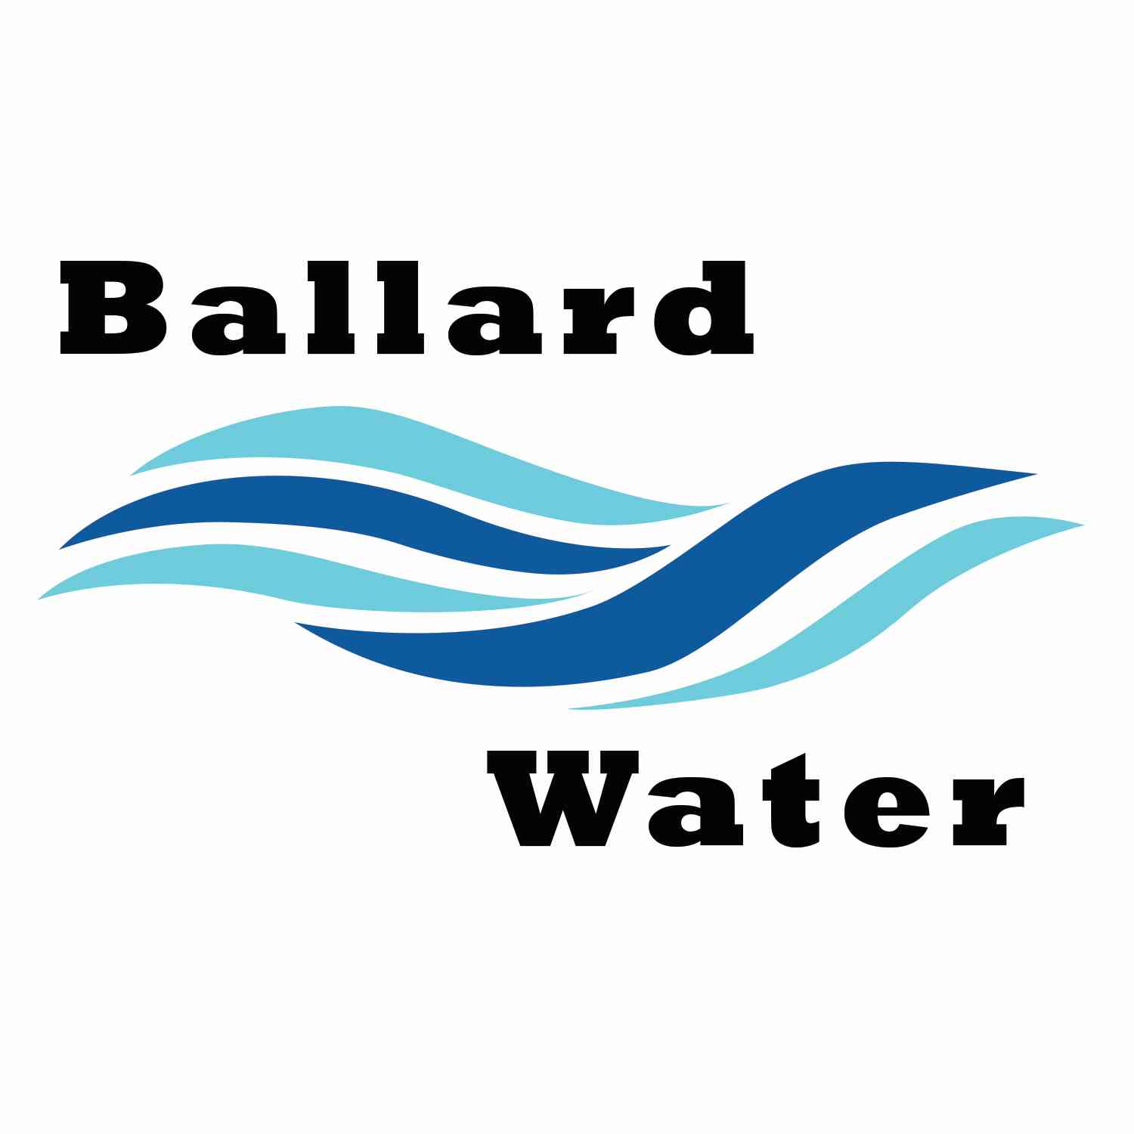

2381 E. 1000 S.

Ballard, UT 84066
Phone: (435) 722-3393
Email: amcdonald@ballardcity.org

Board Chairman

Mark Reidhead

Board Members

Cory O’Driscoll

Andrew Ercanbrack

Ronny Rich

Jesse Danley

Water District Meeting
Visitors
Craig Nebeker
Shaun Murrah
Jeff Baker

AUGUST 20, 2024, 5:30 pm

MINUTES

Item

CALL WATER BOARD MEETING TO ORDER

Welcome and Roll Call – Board Member Andrew Ercanbrack welcomed all in attendance and called roll. Those in attendance were Board Members Ronny Rich, Andrew Ercanbrack, Cory O’Driscoll and Secretary Kaelyn Meyers. Chairman Mark Reidhead and Board Member Jesse Danley was excused.

Prayer – Andrew Ercanbrack

Pledge of Allegiance- Said by all in attendance.

- ENGINEER PROJECT UPDATES –
Water Well Project -- Engineer Craig Nebeker gave an update for the well. There is a 20” diameter hole down 100 feet. They will be sealing the casing tomorrow and witnessed by the state engineer. They will then start next Monday the drilling down another 200 feet which should go faster due to the cobble rock in the first 100 feet. Craig Nebeker stated that they will log the well and see how much water will be received. They are hoping to get 800 gallons a minute. If it only gets 200 gallons a minute it will still be considered a good well. That would serve the residents that we currently have. The well is progressing the way that they wanted.
The water rights will be leased through the Duchesne Water Conservancy District. There are a lot of things that will still need to be done after we see what water we produce.

Lead and Copper Project – the addresses have been submitted and there is about 50 locations that will need a smaller hole. We have until Oct. 16 to have this project complete.

- REVIEW & CORRECT MINUTES –
- June 18, 2024
Motion was made by Board Member Andrew Ercanbrack to accept the Minutes of June 18, 2024 as written. 2nd by Board Member Ronny Rich. All in favor.
Yea Nay
Board Members
Andrew Ercanbrack
Cory O’Driscoll
Ronny Rich
Board Members Mark Reidhead and Jesse Danley were excused.

- July 16, 2024
Motion was made by Board Member Cory O’Driscoll to accept the Minutes of July 16, 2024 as written. 2nd by Board Member Ronny Rich. All in favor.
Yea Nay
Board Members
Andrew Ercanbrack
Cory O’Driscoll
Ronny Rich
Board Members Mark Reidhead and Jesse Danley were excused.

- FOLLOW-UP ON PAST MINUTES –
No follow-up.

- FINANCES: Checks, Statements, Reports and Budget
Checks and finances were gone over and approved.

- ADJOURN WATER BOARD MEETING
Motion was made by Board Member Ronny Rich to adjourn Water Board Meeting at 6:10 p.m. 2nd by Board Member Cory O’Driscoll.
Yea Nay
Board Members
Andrew Ercanbrack
Cory O’Driscoll
Ronny Rich
Board Members Mark Reidhead and Jesse Danley were excused.

______________________________________ __________________________
Chairman Mark Reidhead Date

______________________________________ __________________________
Secretary Anissa McDonald Date

