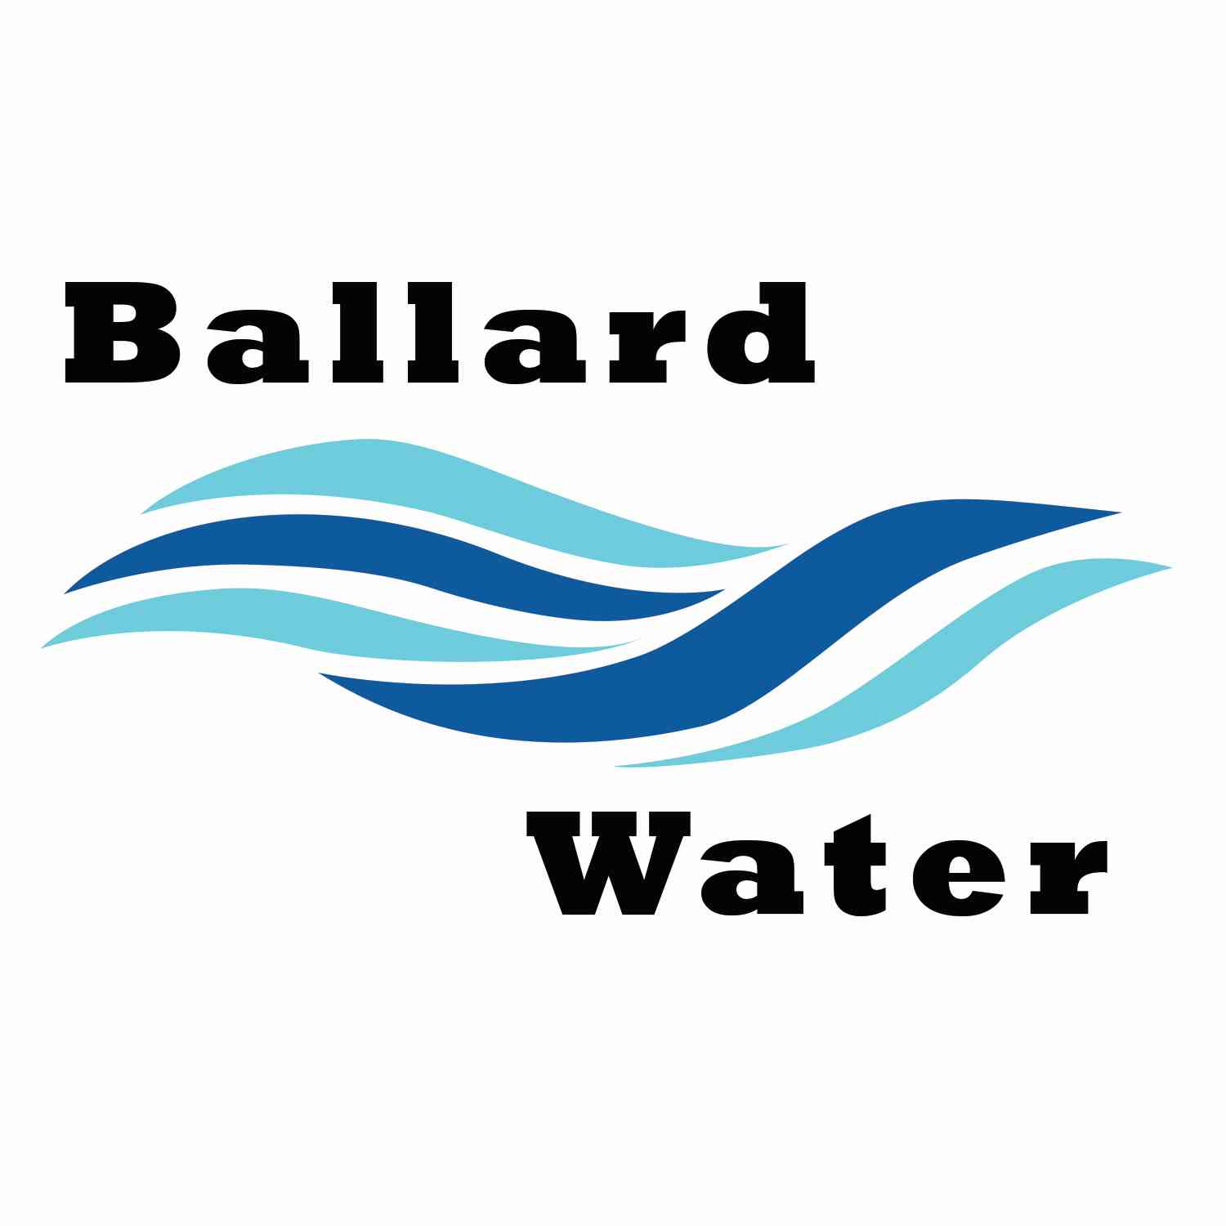

2381 E. 1000 S.

Ballard, UT 84066
Phone: (435) 722-3393
Email: amcdonald@ballardcity.org

Board Chairman

Mark Reidhead

Board Members

Cory O’Driscoll

Andrew Ercanbrack

Ronny Rich

Jesse Danley

Water District Meeting
Visitors
Craig Nebeker
Shaun Murray
Robert Abercrombie

APRIL 16, 2024, 5:30 pm

MINUTES

Item

CALL WATER BOARD MEETING TO ORDER

Welcome and Roll Call – Chairman Mark Reidhead welcomed all in attendance and called roll. Those in attendance are Board Members Cory O’Driscoll, Andrew Ercanbrack, Ronny Rich, Jesse Danley, and Secretary Kaelyn Meyers. Secretary Anissa McDonald was excused.

Prayer – Ronny Rich

Pledge of Allegiance- was said by all present

- 2024 CIB 1YR PROJECT LIST –
Mayor Bob Abercrombie was in attendance and explained that coming up soon is a meeting in Duchesne where CIB will discuss the applications that will be presented and will vote on whether they will send them to the state CIB board for funding. Chairman Mark Reidhead stated that we will have to have a representative there if we want to go for any funding from the 1-year list. If Mayor Abercrombie finds out anything about the meeting, he will let Chairman Mark Reidhead know when and where. It depends on what our budget is regarding the Well Project whether we can carry any more debt for more projects.

- ENGINEER PROJECT UPDATES –
Well Project Report – CRS Engineer Craig Nebeker stated that there is good news regarding the Well project, they received permission from the division of drinking water for the drilling of the well. We have put the project out for bid and by the next meeting we will be selecting a well driller. After they start the exploratory well it will take about a month to answer questions regarding the water that is there. Converting from the exploratory well to the actual well will make it into a usable well and then from there will be a time that we will have to work with the state for approval.

Lead and Copper Update – 237 homes still need to be found and 20 percent will need to be sampled. They are still working on this project.

Property Purchase – Chairman Mark Reidhead stated that Ben Mower and Jeff Baker from Jones & Demille have been speaking with properties owners just north of the well property from Killian’s. There are about 50 acres that the property owners are willing to sell to the district. Total with the water well there would be about 68 acres. It was asked if water rights would be included with that property. Chairman Mark Reidhead stated that this would secure our protection zone for the well site. This piece of property would be a landlocked piece of property. There would be restrictions as to contaminants regardless of who owns the property.
Engineer Craig Nebeker stated that in the future there could be a benefit with drilling another well within the same proximity to the first well for maximum benefit if ever needed. Roosevelt City has done this same thing. Chairman Mark Reidhead asked where we are already contracted for 10 acres, would there be room to put another well in that 10 acres and still have that protection zone. It was stated that it might be possible, but we would possibly want more property at that time.
Engineer Craig Nebeker stated that the public might feel differently about the use of the funds if we purchase the property at this time. It was asked if we need a public hearing. Mayor Abercrombie stated that we don’t know what the future will bring, and we might need to drill 2 or three more wells, and this might be a good investment.
Board Member Cory O’Driscoll stated that if the pilot well does well and things work out it might be a good thing to investigate the purchase of the 60 acres. Board Member Jesse Danley asked what we need to do to purchase it. Board Member Andrew Ercanbrack stated that it is a good opportunity and that we might not get another time. Chairman Mark Reidhead will find out more before we finalize anything.

- REVIEW & CORRECT MINUTES –
- March 19, 2024
Motion was made by Board Member Andrew Ercanbrack to approve the Minutes of March 19, 2024 as written. 2nd by Board Member Ronny Rich. All in favor.
Yea Nay
Board Members
Mark Reidhead
Cory O’Driscoll
Andrew Ercanbrack
Ronny Rich
Jesse Danley

- FOLLOW-UP ON PAST MINUTES
No follow-up

- FINANCES: Checks, Statements, Reports and Budget
Finances were gone over and approved.

- ADJOURN WATER BOARD MEETING
Motion was made by Board Member Jesse Danley to adjourn Water Board Meeting at 6:15 p.m. 2nd by Board Member Andrew Ercanbrack. All in favor.
Yea Nay
Board Members
Mark Reidhead
Cory O’Driscoll
Andrew Ercanbrack
Ronny Rich
Jesse Danley

__________________________________ _______________________
Chairman Mark Reidhead Date

__________________________________ _______________________
Secretary Anissa McDonald Date

