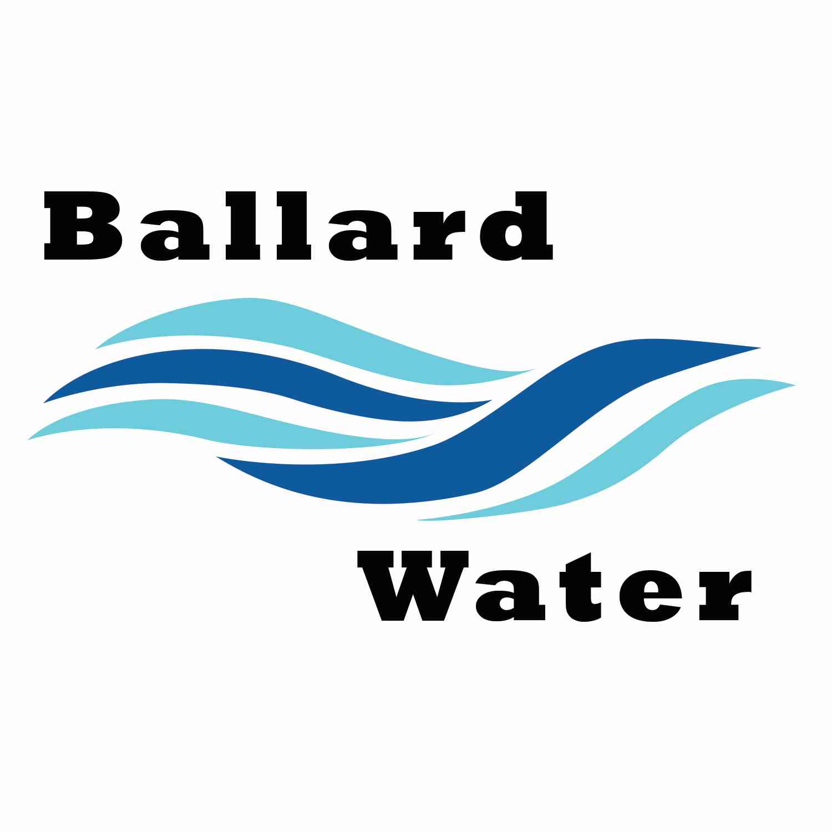

2381 E. 1000 S.

Ballard, UT 84066
Phone: (435) 722-3393
Email: amcdonald@ballardcity.org

Board Chairman

Mark Reidhead

Board Members

Bob Abercrombie

Andrew Ercanbrack

Ronny Rich

Jesse Danley

Water District Meeting

September 19, 2023, 5:30 pm

AGENDA

Item

CALL WATER BOARD MEETING TO ORDER

Welcome and Roll Call –

Prayer – Mark Reidhead

Pledge of Allegiance-

- FIRE SUPPRESSION– James & Loni Costello
- FIRE SUPPRESSION – Joe Archer
- PARAMETERS RESOLUTION FOR WATER REVENUE BONDS –
A RESOLUTION AUTHORIZING NOT MORE THAN $5,000,000 TAXABLE WATER REVENUE BONDS, IN ONE OR MORE SERIES, FOR WATER SYSTEN IMPROVEMENTS, AND RELATED IMPROVEMENTS; PROVIDING FOR THE PUBLICATION OF A NOTICE OF PUBLIC HEARING AND BONDS TO BE ISSUED; FIXING THE MAXIMUM PRINCIPAL AMOUNT, INTEREST RATE, MATURITY, AND DISCOUNT OF THE BONDS; PROVIDING FOR THE RUNNING OF A CONTEST PERIOD; AND RELATED MATTERS.
- CLOSED SESSION -
- ENGINEER PROJECT UPDATES –
- REVIEW & CORRECT MINUTES –
- August 15, 2023
- FOLLOW-UP ON PAST MINUTES
- FINANCES: Checks, Statements, Reports and Budget
- ADJOURN WATER BOARD MEETING

*NOTE: In compliance with the Americans with Disabilities Act, individuals needing special accommodations during this meeting should notify Kaelyn Meyers at Ballard City Building, 2381 E. 1000 S., Ballard, Utah 84066: Phone: 435-722-3393.

