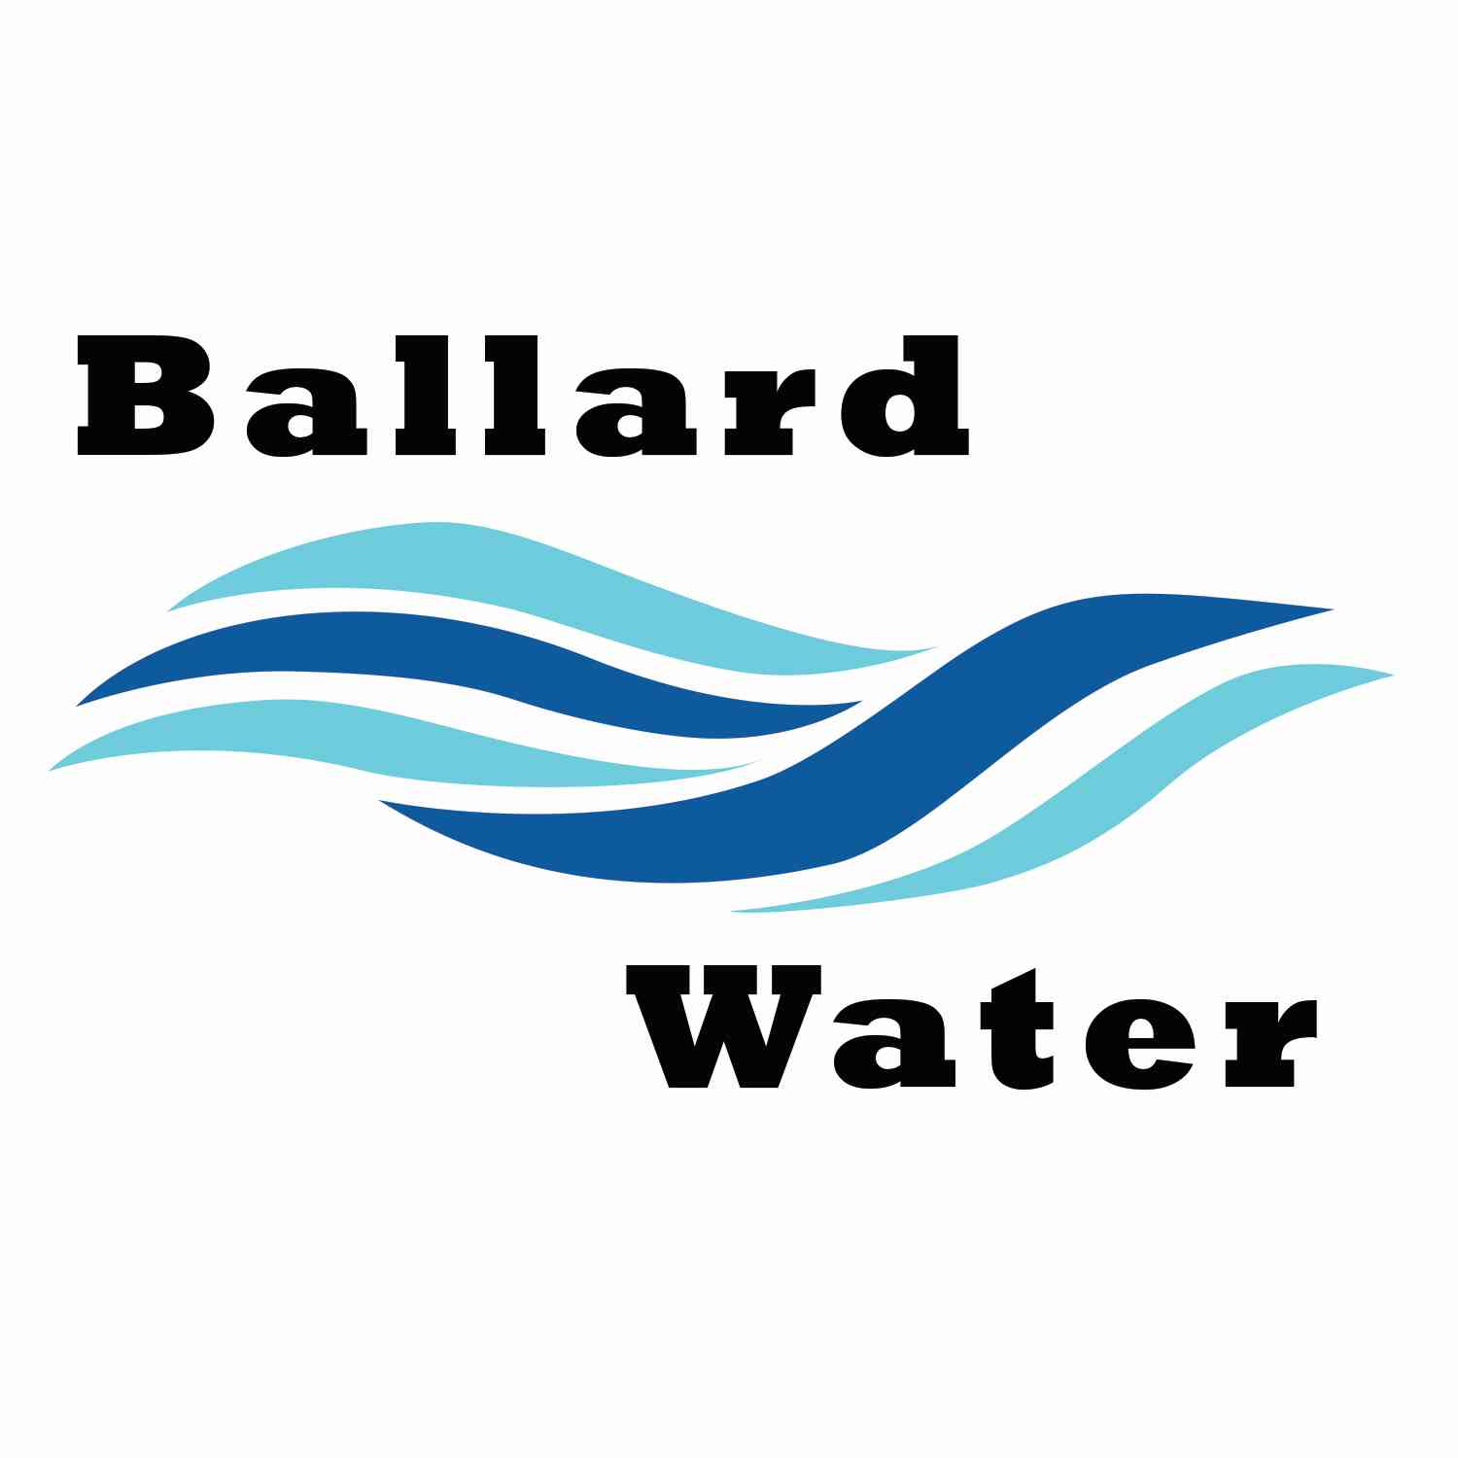

2381 E. 1000 S.

Ballard, UT 84066
Phone: (435) 722-3393
Email: amcdonald@ballardcity.org

Board Chairman

Mark Reidhead

Board Members

Bob Abercrombie

Andrew Ercanbrack

Ronny Rich

Jesse Danley

Water District Meeting

October 17, 2023, 5:30 pm

AGENDA

Item

CALL WATER BOARD MEETING TO ORDER

Welcome and Roll Call –

Prayer – Bob Abercrombie

Pledge of Allegiance-

- FIRE SUPPRESSION– Joe Archer
- WATER CONNECTION – Joe & Linda Bowden
- FINAL BOND RESOLUTION FOR WATER REVENUE BONDS –
A RESOLUTION AUTHORIZING $3,600,000 TAXABLE WATER REVENUE BONDS, SERIES 2023, FOR THE PURPOSE OF FINANCING A PORTION OF THE COSTS OF WATER SYSTEM IMPROVEMENTS, AND RELATED INPROVEMENTS; AND RELATED MATTERS.
- RESOLUTION #2310-001 CANCELING WATER DISTRICT ELECTION–
- SEWER CONNECTION – Troy Gadd
- ENGINEER PROJECT UPDATES –
- REVIEW & CORRECT MINUTES –
- September 19, 2023
- FOLLOW-UP ON PAST MINUTES
- FINANCES: Checks, Statements, Reports and Budget
- ADJOURN WATER BOARD MEETING

*NOTE: In compliance with the Americans with Disabilities Act, individuals needing special accommodations during this meeting should notify Kaelyn Meyers at Ballard City Building, 2381 E. 1000 S., Ballard, Utah 84066: Phone: 435-722-3393.

