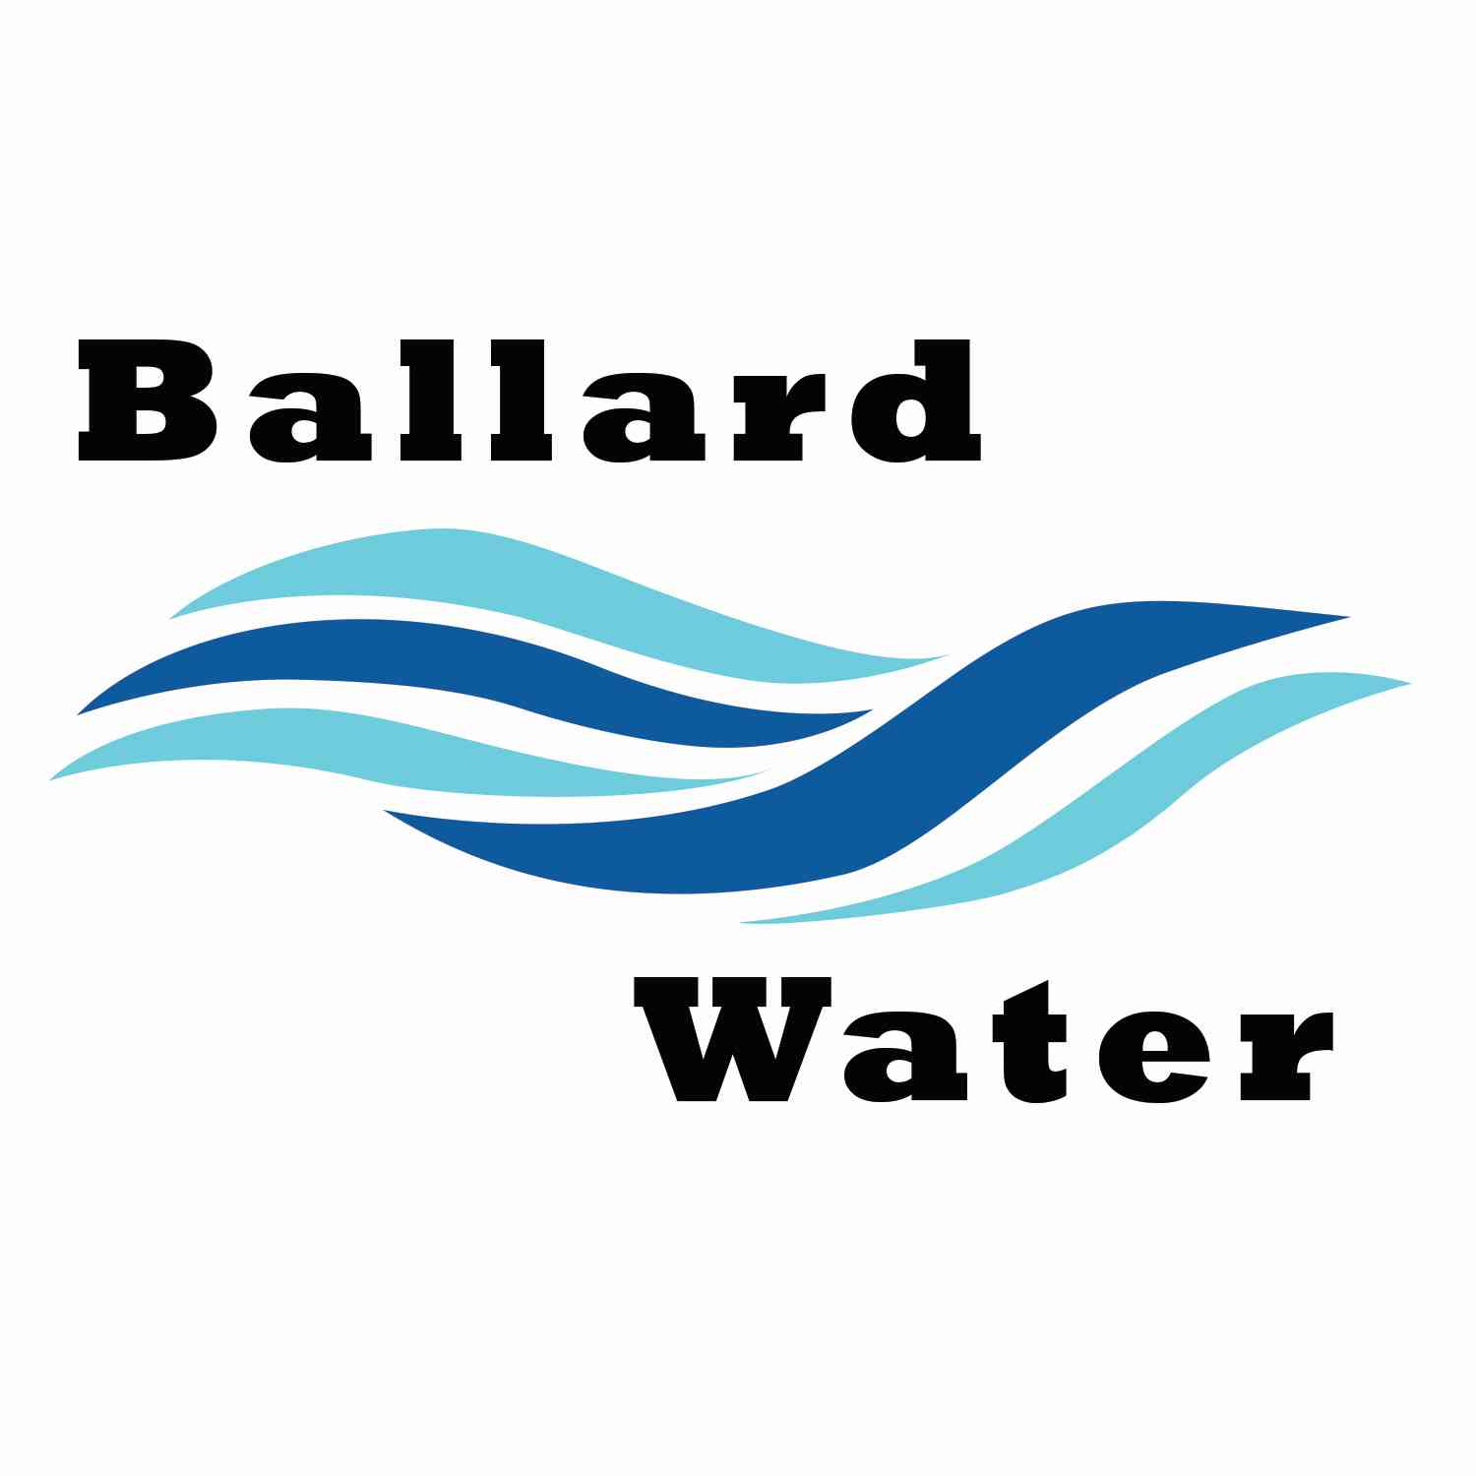

2381 E. 1000 S.

Ballard, UT 84066
Phone: (435) 722-3393
Email: amcdonald@ballardcity.org

Board Chairman

Mark Reidhead

Board Members

Cory O’Driscoll

Andrew Ercanbrack

Ronny Rich

Jesse Danley

Water District Meeting

AUGUST 20, 2024, 5:30 pm

AGENDA

Item

CALL WATER BOARD MEETING TO ORDER

Welcome and Roll Call –

Prayer – Andrew Ercanbrack

Pledge of Allegiance-

- ENGINEER PROJECT UPDATES –
- REVIEW & CORRECT MINUTES –
- June 18, 2024
- July 16, 2024
- FOLLOW-UP ON PAST MINUTES
- FINANCES: Checks, Statements, Reports and Budget
- ADJOURN WATER BOARD MEETING

*NOTE: In compliance with the Americans with Disabilities Act, individuals needing special accommodations during this meeting should notify Kaelyn Meyers at Ballard City Building, 2381 E. 1000 S., Ballard, Utah 84066: Phone: 435-722-3393.

